11/25/2024

|  |
| --- |
| question | YASH |



|  |  |
| --- | --- |
| By Yash | Stats Interview question |



**Question 1**: *What are the most important topics in statistics?*

**Answer**:  
The most important topics in statistics depend on the application, but the foundational ones include:

* **Descriptive Statistics**: Measures like mean, median, standard deviation, and visualization techniques are crucial for summarizing and understanding data. For example, I use histograms and boxplots to detect data anomalies and trends.
* **Probability Theory**: Understanding concepts like probability distributions (e.g., Normal, Binomial) is key. In a project involving risk modeling, I applied the Poisson distribution to model rare events.
* **Inferential Statistics**: Hypothesis testing and confidence intervals are critical for drawing conclusions. For example, I used a t-test to compare means of two groups in an A/B testing experiment.
* **Regression Analysis**: Linear and logistic regression are the backbone of predictive modeling. In one project, I built a multiple regression model to forecast sales based on pricing and advertising spend.
* **Time Series Analysis**: Techniques like ARIMA and Exponential Smoothing are essential for handling temporal data, such as predicting stock prices or customer demand.
* **Statistical Inference**: Central Limit Theorem and sampling techniques underpin decision-making when working with sample data, ensuring results are generalizable.
* 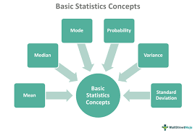

**Question 2** : *What is exploratory data analysis (EDA)?*

**Answer**:  
Exploratory Data Analysis (EDA) is the process of analyzing and visualizing datasets to uncover patterns, spot anomalies, test hypotheses, and check assumptions before applying statistical or machine learning models.

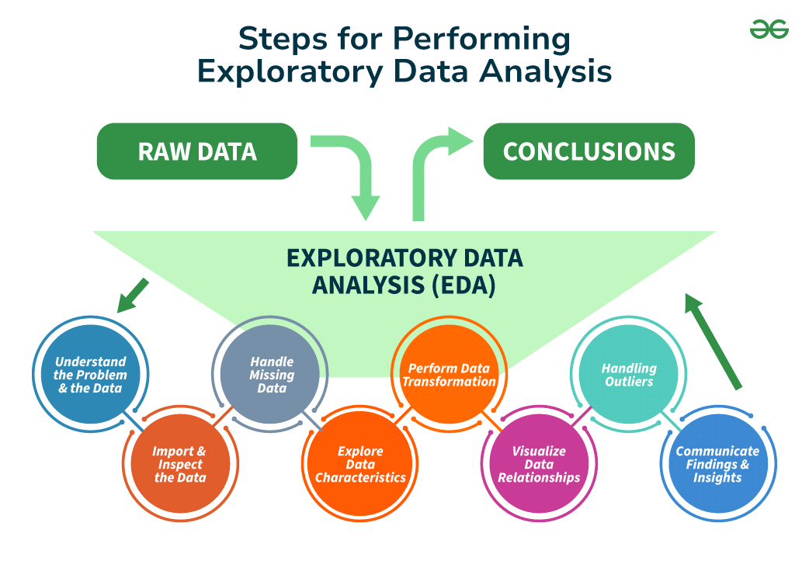

It typically involves:

* **Summary Statistics**: Calculating measures like mean, median, mode, variance, and standard deviation to understand data distributions. For example, in a dataset of customer purchases, EDA helps identify average spending and variability.
* **Data Visualization**: Using plots like histograms, boxplots, scatterplots, and correlation matrices to identify relationships or trends. For instance, scatterplots can reveal linear or non-linear relationships between features.
* **Identifying Missing or Outlier Data**: Detecting incomplete data and extreme values, which might distort analysis. For example, during EDA, I’ve identified missing income data in a survey and addressed it using imputation techniques.
* **Data Cleaning**: Correcting inconsistencies, handling missing values, and transforming variables for further analysis. For example, normalizing skewed features before modeling.

**Question 3**: *What are quantitative data and qualitative data?*

**Answer**:

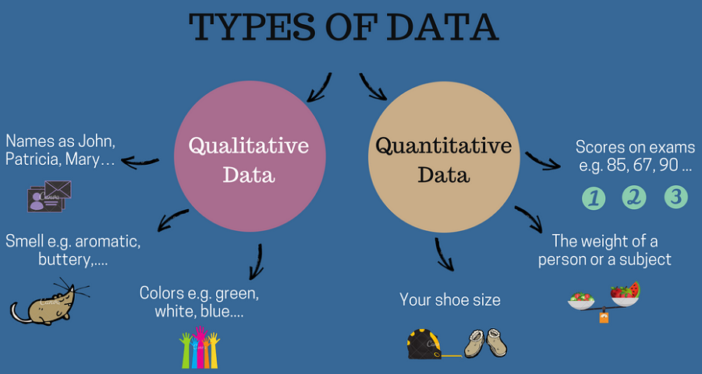

**Quantitative Data**:

* Quantitative data represents numerical values that can be measured and quantified. It is used for performing mathematical operations and statistical analysis.
* It is often divided into:
* **Discrete Data**: Countable values, such as the number of students in a class.
* **Continuous Data**: Measurable values that can take any value within a range, such as height or temperature.

For example, in a sales dataset, the revenue earned (e.g., $10,000) is quantitative data.

**Qualitative Data**:

* Qualitative data represents descriptive or categorical information, which cannot be measured numerically but can be classified into categories.
* It is divided into:
* **Nominal Data**: Categories without an inherent order, like gender or city names.
* **Ordinal Data**: Categories with a meaningful order, like customer satisfaction levels (e.g., "Satisfied," "Neutral," "Dissatisfied").

For instance, in a survey, responses about a customer's preferred product brand (e.g., "Brand A" or "Brand B") are qualitative data.

Both types of data play complementary roles in analysis, with quantitative data offering numerical insights and qualitative data providing contextual understanding.

**Question 4**: *What is the meaning of KPI in statistics?*

**Answer**:  
KPI stands for **Key Performance Indicator**, a measurable value that indicates how effectively an individual, team, or organization is achieving specific objectives.

In statistics, KPIs are used to quantify performance and monitor progress over time. They are often tied to business goals, operational efficiency, or project success.

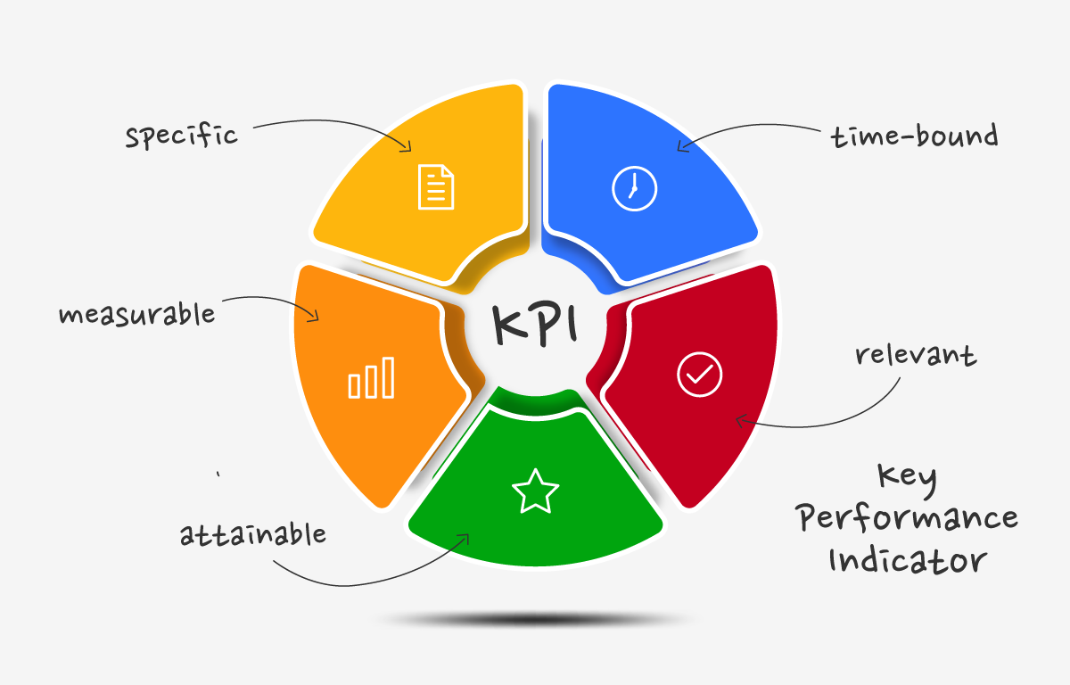

Key characteristics of a good KPI include:

* **Specific and Relevant**: Directly tied to objectives. For example, in a sales department, "Monthly Revenue Growth" is a relevant KPI.
* **Measurable**: Quantifiable, such as "Conversion Rate" or "Average Customer Retention Rate."
* **Actionable**: Provides insights that can guide decision-making.

**Example**:  
In a marketing campaign, a KPI could be "Click-Through Rate (CTR)" to measure the effectiveness of email advertisements.

KPIs help decision-makers focus on critical metrics, evaluate strategies, and align actions with organizational goals. They are often visualized using dashboards for continuous monitoring.

**Question 5**: *What is the difference between univariate, bivariate, and multivariate analysis?*

**Answer**:  
The differences lie in the number of variables analyzed and the relationships being explored:

1. Univariate Analysis

* **Definition**: Examines a single variable to summarize its characteristics.
* **Purpose**: Focuses on descriptive statistics (mean, median, mode) and data visualization (e.g., histograms, boxplots).
* **Example**: Analyzing the average height of students in a class.

2. Bivariate Analysis

* **Definition**: Explores the relationship between two variables to identify associations, dependencies, or patterns.
* **Techniques**:
* Numerical Data: Correlation, Simple Linear Regression
* Categorical Data: Contingency Tables, Chi-square Test
* **Example**: Analyzing the relationship between study hours and exam scores using a scatterplot or correlation coefficient.

3. Multivariate Analysis

* **Definition**: Involves three or more variables to examine their interrelationships or combined effects.
* **Techniques**:
* Multivariate Regression
* Principal Component Analysis (PCA)
* Cluster Analysis
* **Example**: Analyzing the effect of marketing spend, product price, and seasonality on sales.

Each type of analysis is used depending on the complexity of the data and the research question. For instance, univariate is useful for initial exploration, while bivariate and multivariate are essential for identifying patterns and predictive modeling.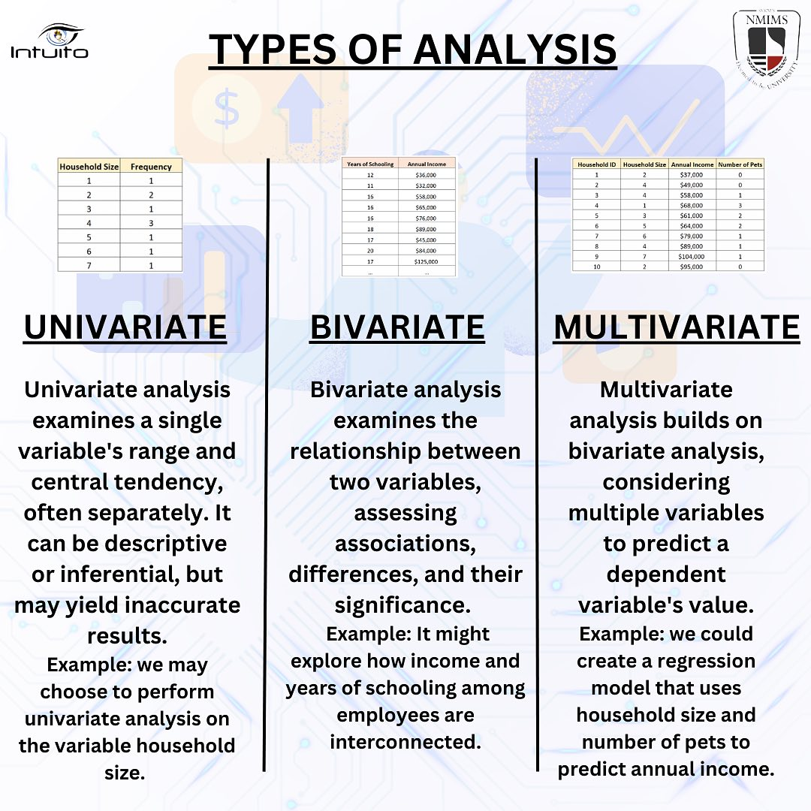

**Question 6**: *How would you approach a dataset that’s missing more than 30 percent of its values?*

**Answer**: 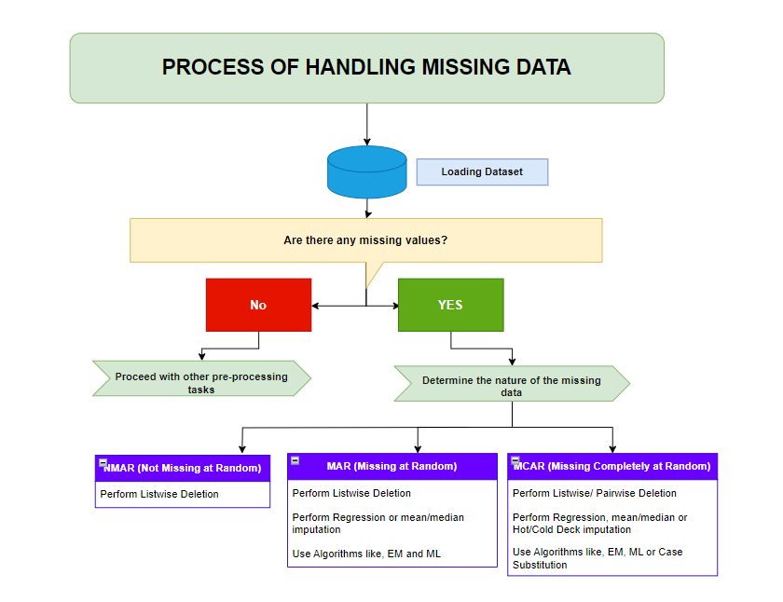  
When dealing with a dataset with more than 30% missing values, I would follow a structured approach to ensure meaningful analysis while minimizing bias:

1. Understand the Data

* **Examine the Pattern of Missingness**: First, I would assess whether the missing values are **random** (Missing Completely at Random - MCAR), **random but dependent on other variables** (Missing at Random - MAR), or **not random** (Not Missing at Random - NMAR). This informs the strategy for handling them.
* **Check Correlation**: Determine if the missing data is correlated with any other variables or external factors. If certain features have high missingness, it may indicate an underlying issue.

2. Assess Impact on Analysis

* **Determine the Importance of the Missing Data**: Evaluate how the missing values impact key variables, the analysis goals, and model performance. If key variables are missing, removing them may result in significant information loss.

3. Strategies for Handling Missing Data

Depending on the context, I’d consider several strategies:

* **Imputation**:
* For **numerical data**, I may impute using techniques like **mean/median imputation** (if missingness is random) or more advanced methods like **K-Nearest Neighbors (KNN)**, **Multiple Imputation**, or **Regression Imputation**.
* For **categorical data**, I could impute using the **mode** or use **predictive models** to fill in missing values.
* **Removing Data**:
* **Removing Missing Columns**: If more than 30% of a feature is missing and it’s not critical to the analysis, I might drop the feature entirely.
* **Removing Missing Rows**: If a significant number of rows are missing values for critical features, I might remove those rows but only if it doesn’t compromise the integrity of the dataset.
* **Using Algorithms That Handle Missing Data**: Some models (e.g., tree-based models like Random Forest) can handle missing data internally, so using such algorithms may reduce the need for imputation or row removal.

4. Consider External Data

* If missing data is systematic (e.g., due to a sensor failure or a particular time period), I would look into collecting external data or using domain knowledge to estimate the missing values.

5. Evaluate After Imputation

* Once I've addressed the missing values, I would evaluate the performance of the model or analysis on the imputed data to ensure that it’s still robust and not introducing bias.

By carefully assessing the type of missingness and applying appropriate imputation techniques or removal strategies, I can make the dataset more usable for analysis without compromising its integrity.

**Question 7**: *Give an example where the median is a better measure than the mean.*

**Answer**:  
The **median** is often a better measure than the **mean** when dealing with **skewed data** or **outliers**. A classic example is **income distribution** in a population.

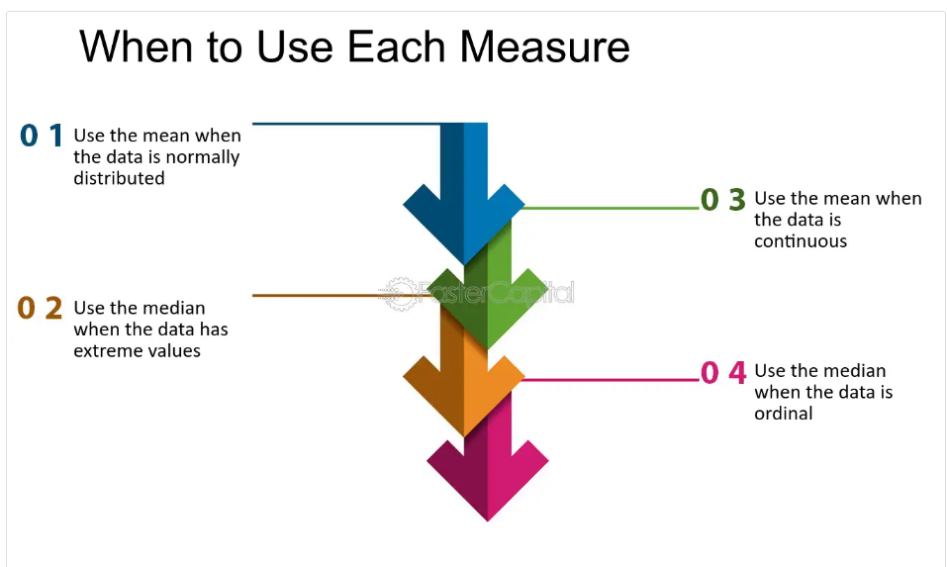

For example, consider a dataset of household incomes:

* $30,000, $32,000, $35,000, $36,000, $300,000, $500,000, $2,000,000

The **mean income** in this dataset is $704,000, which is heavily influenced by the extreme outlier of $2,000,000. The **median income**, however, is $36,000, which better reflects the typical household income in this population, as it is not distorted by extreme values.

In cases like these, the **median** gives a more accurate representation of the central tendency of the data.

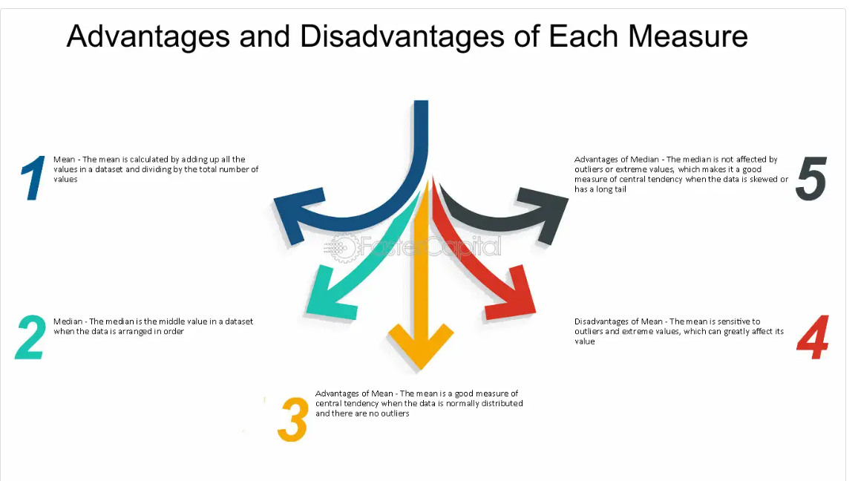

**Question 8**: *What is the difference between Descriptive and Inferential Statistics?*

**Answer**:

* **Descriptive Statistics**:
* **Purpose**: Summarizes or describes the main features of a dataset.
* **Methods**: Includes measures like mean, median, mode, standard deviation, and visualizations like histograms or boxplots.
* **Example**: A company analyzing its monthly sales data to calculate the average sales and create a distribution of those sales.

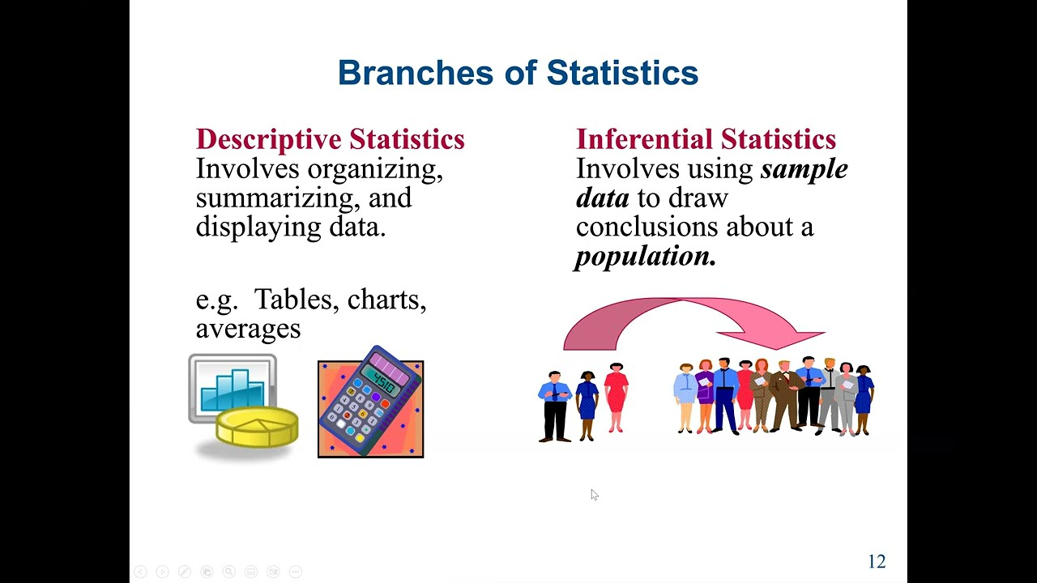

* **Inferential Statistics**:
* **Purpose**: Makes predictions or inferences about a larger population based on a sample. It helps generalize findings beyond the data at hand.
* **Methods**: Involves hypothesis testing, confidence intervals, regression analysis, and other techniques to draw conclusions.
* **Example**: Using a sample of 500 customers to estimate the average spending of all customers in a region, or conducting a t-test to compare two groups' means.

**In summary**, descriptive statistics is used to summarize and explore data, while inferential statistics is used to make predictions or generalizations about a population based on a sample.

**Question 9**: *What are descriptive statistics?*

**Answer**:  
**Descriptive statistics** involves summarizing or describing the main features of a dataset. It provides simple summaries about the sample and the measures. Descriptive statistics is broken down into three key components:

* **Distribution**: This refers to how the data points are spread or arranged. It can be visualized using histograms, frequency tables, or probability distributions. Distribution helps us understand the frequency of various responses in the dataset.
* **Example**: A frequency distribution of exam scores showing how many students scored in each range (e.g., 50-60%, 60-70%, etc.).
* **Central Tendency**: This provides a measure of the "center" of the data. The common measures are:
* **Mean**: The average value.
* **Median**: The middle value when data is ordered.
* **Mode**: The most frequent value.
* **Example**: For the set of scores [2, 3, 3, 4, 8], the mean is 4, the median is 3, and the mode is 3.
* **Variability**: This describes the spread or dispersion of the data. Common measures include:
* **Range**: Difference between the maximum and minimum values.
* **Variance**: The average squared deviation from the mean.
* **Standard Deviation**: A measure of the spread of data points around the mean.
* **Example**: A dataset with values [2, 3, 4, 5, 6] has lower variability than a dataset with values [1, 2, 10, 20, 50] because the latter has a greater spread.

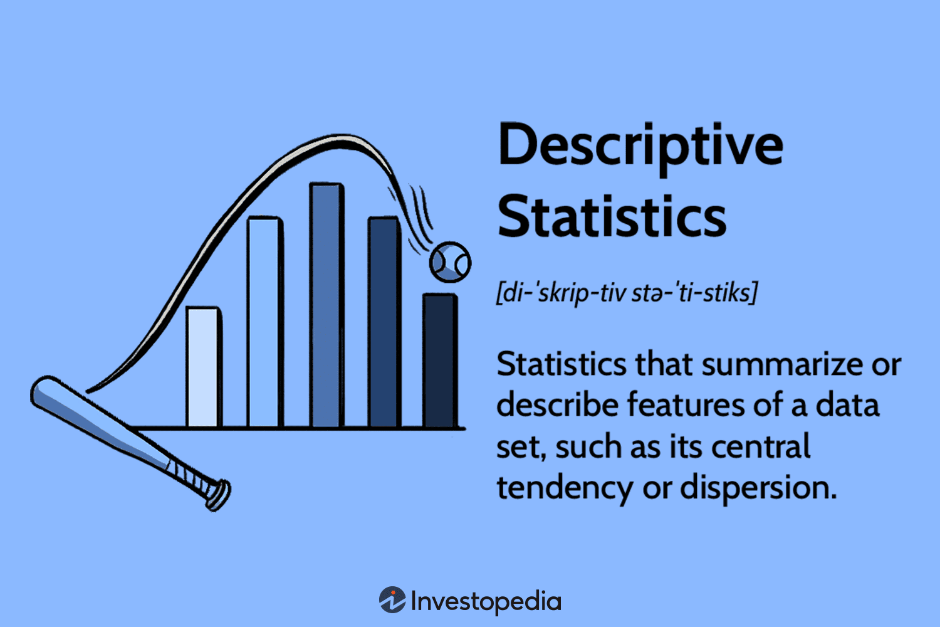

**Question 10**: *Can you state the method of dispersion of the data in statistics?*

**Answer**:  
The **methods of dispersion** in statistics measure the extent to which data points deviate from the central value. Common measures of dispersion are:

* **Range**: The difference between the maximum and minimum values in the dataset.
* Formula: **Range = Maximum Value - Minimum Value**
* **Variance**: The average of the squared differences from the mean. It quantifies how spread out the data points are.
* Formula: Variance=1n∑(xi−μ)2\text{Variance} = \frac{1}{n} \sum (x_i - \mu)^2 where xix_i is each individual data point, and μ\mu is the mean.
* **Standard Deviation**: The square root of the variance, providing a measure of the spread in the same units as the data.
* Formula: Standard Deviation=Variance\text{Standard Deviation} = \sqrt{\text{Variance}}

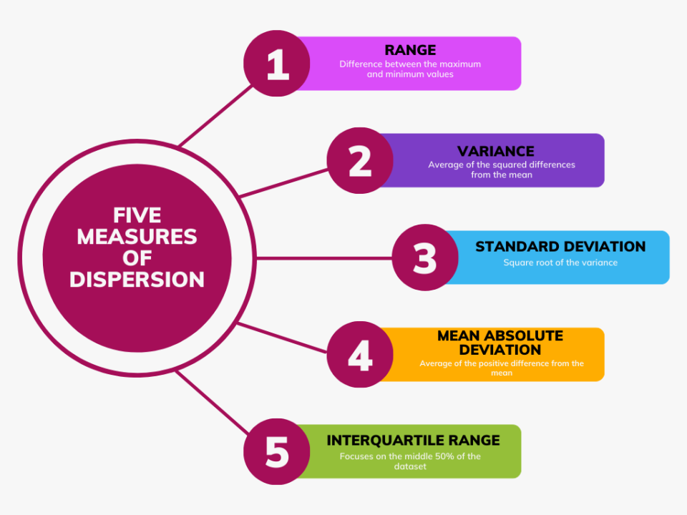

These methods help assess how much individual data points deviate from the central tendency of the data.

**Question 3**: *How can we calculate the range of the data?*

**Answer**:  
The **range** is calculated by subtracting the **minimum value** of the dataset from the **maximum value**.

* **Formula**: Range=Maximum Value−Minimum Value\text{Range} = \text{Maximum Value} - \text{Minimum Value}

For example, if the dataset is [4, 7, 1, 10, 3], the range would be:

* **Range = 10 - 1 = 9**

The range provides a simple measure of the spread of the data.

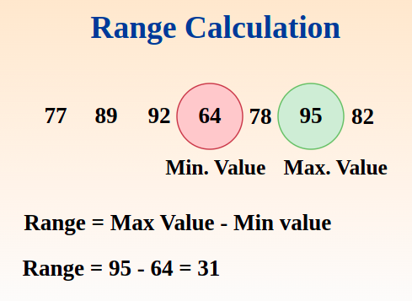

**Question 4**: *Is the range sensitive to outliers?*

**Answer**:

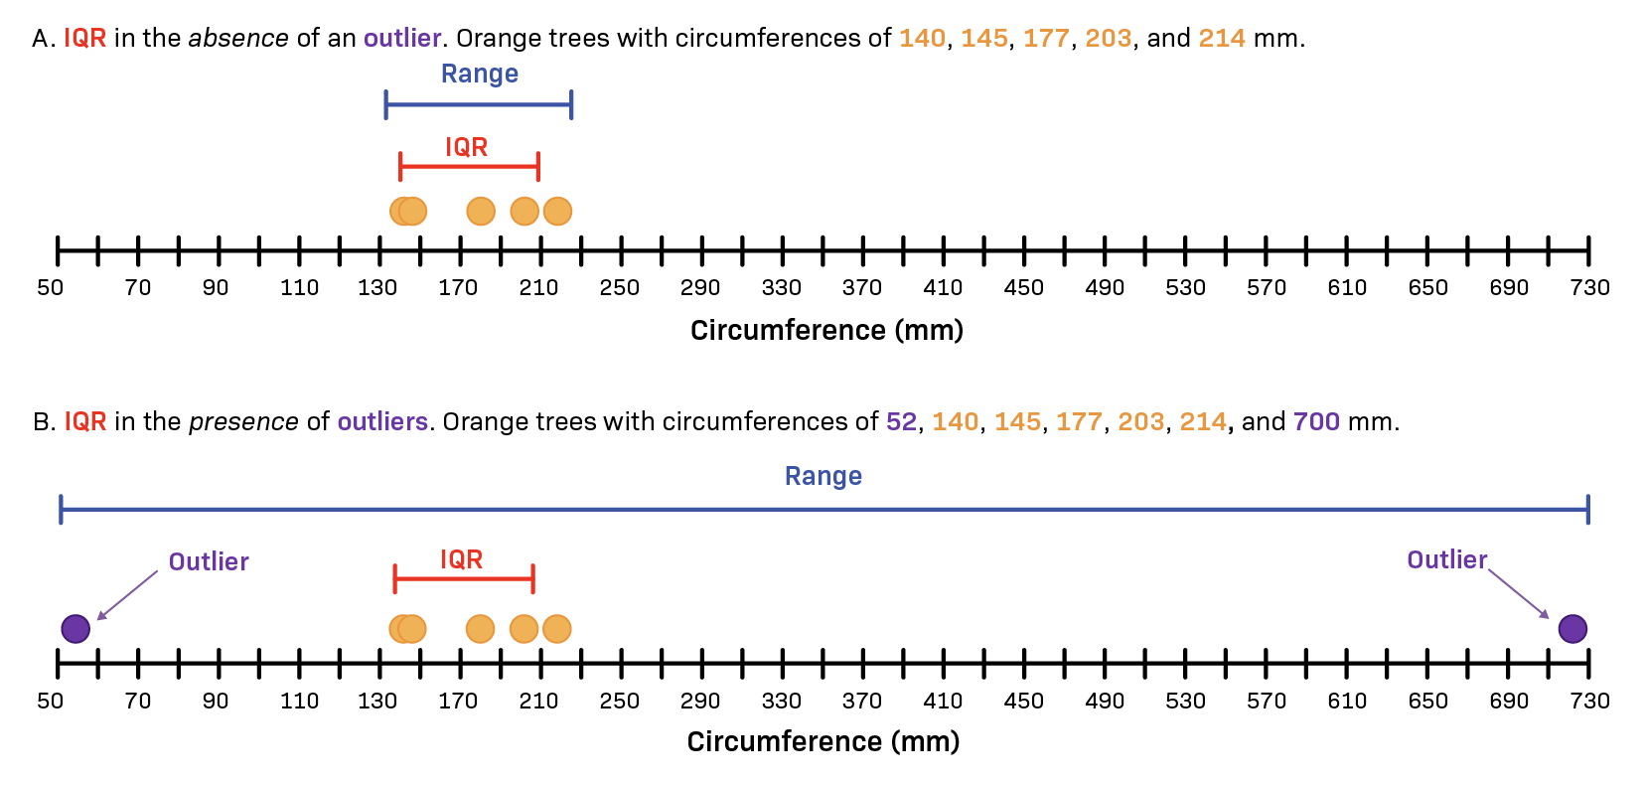  
Yes, the **range** is highly sensitive to **outliers**. Since the range depends only on the maximum and minimum values, extreme outliers can significantly increase the range, even if most data points are clustered around a central value.

For example, in a dataset [1, 2, 3, 4, 1000], the range is **1000 - 1 = 999**, which is largely influenced by the outlier value of 1000, even though the majority of the data points are much smaller.

**Question 5**: *What is the meaning of standard deviation?*

**Answer**:  
**Standard deviation** is a measure of the amount of variation or dispersion in a set of data. It quantifies how spread out the data points are around the **mean**. A low standard deviation means the data points are close to the mean, while a high standard deviation indicates that the data points are spread out over a wide range of values.

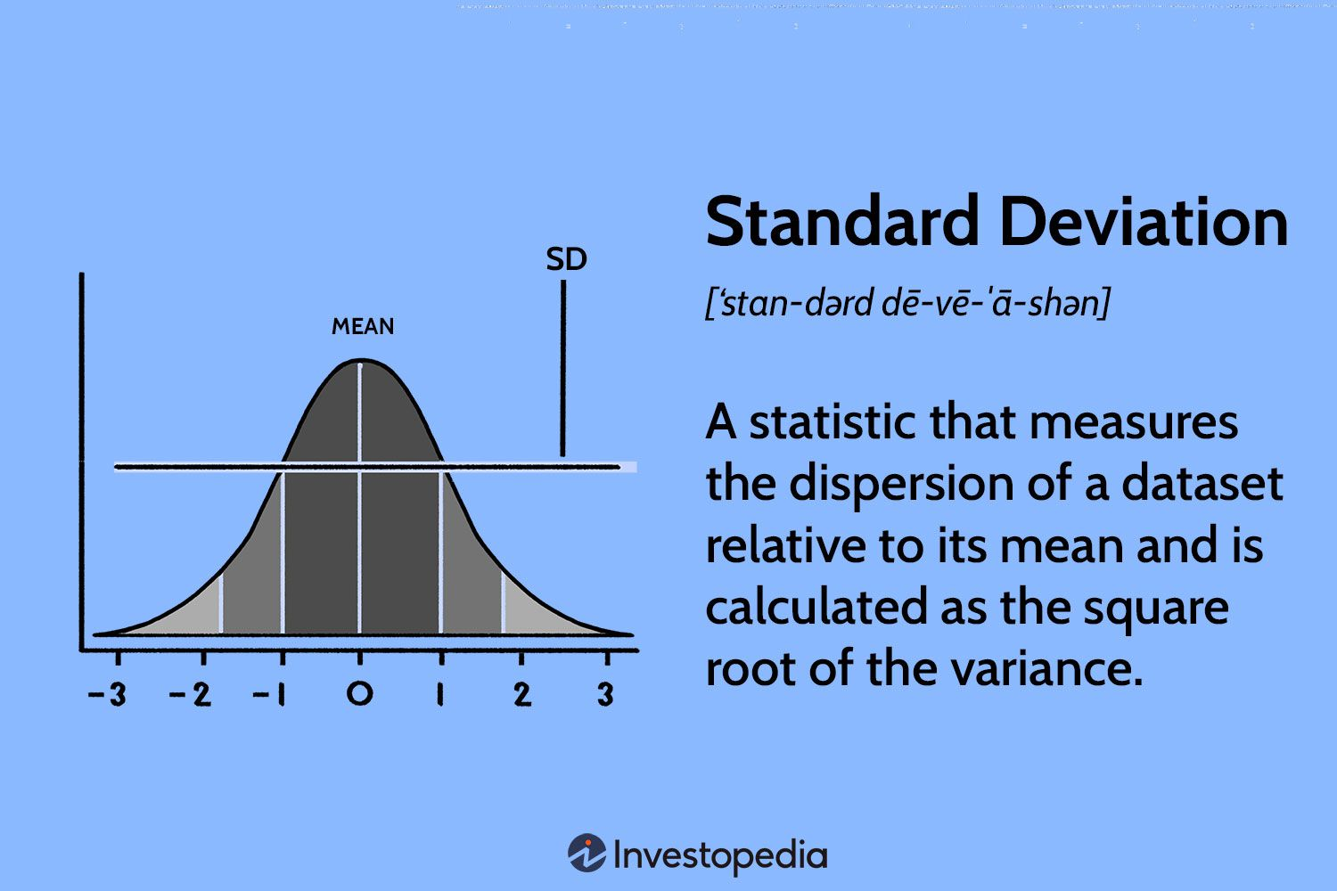

* **Formula**: Standard Deviation=1n∑(xi−μ)2\text{Standard Deviation} = \sqrt{\frac{1}{n} \sum (x_i - \mu)^2} where xix_i is each data point, μ\mu is the mean, and nn is the number of data points.

For example, for the data [2, 4, 6, 8, 10], the standard deviation is relatively low because the data points are close to the mean (6). On the other hand, in a dataset like [1, 5, 9, 15, 20], the standard deviation is higher because the values are spread farther from the mean.

**Question 1**: *What are the scenarios where outliers are kept in the data?*

**Answer**:  
Outliers are typically removed if they are errors or anomalies, but there are scenarios where **outliers are kept** in the data, such as:

* **Natural Variability**: If outliers represent rare but valid occurrences in the data (e.g., extreme sales spikes during holidays), they are retained. Removing them would distort the analysis or model.
* **Domain Knowledge**: In certain fields like finance, medical studies, or climate data, outliers may represent important signals or phenomena that cannot be ignored (e.g., extremely high income or rare diseases).

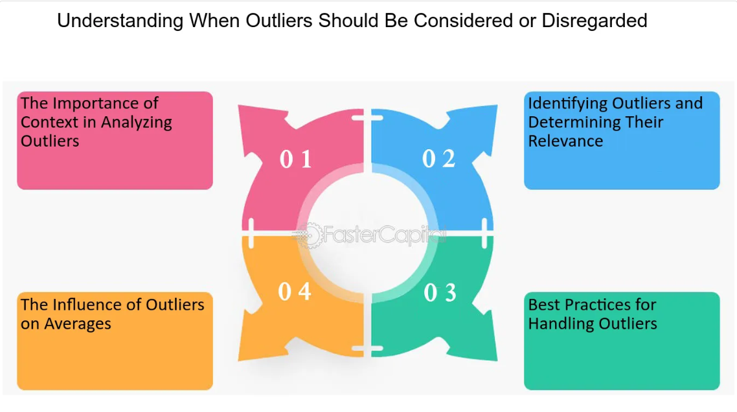

* **No Impact on Analysis**: In some cases, the presence of outliers may not significantly impact the analysis or conclusions, especially when the sample size is large, and the outliers are still within the bounds of the data distribution.
* **Purpose of Robust Analysis**: If the focus is on using robust statistical methods (e.g., median instead of mean), outliers can provide meaningful insights without distorting the result.

**Question 2**: *What is Bessel's correction?* 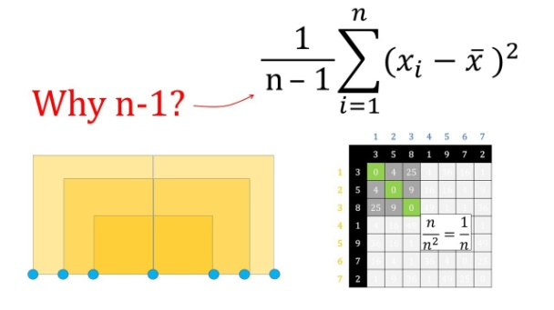

**Answer**:  
**Bessel’s correction** is a method used to correct the bias in the estimation of the population variance and standard deviation when working with a **sample** rather than the entire population. It involves using **n-1** instead of **n** in the denominator of the variance and standard deviation formulas, where **n** is the sample size.

Without Bessel’s correction, the sample variance tends to underestimate the population variance, especially in small samples. By using **n-1**, we get a **better estimate of the true population variance**, making the sample statistics more accurate.

* **Formula without Bessel’s correction** (biased): Variance=1n∑(xi−μ)2\text{Variance} = \frac{1}{n} \sum (x_i - \mu)^2
* **Formula with Bessel’s correction** (unbiased): Variance=1n−1∑(xi−μ)2\text{Variance} = \frac{1}{n-1} \sum (x_i - \mu)^2

**Question 3**: *What do you understand about a spread out and concentrated curve?*

**Answer**:

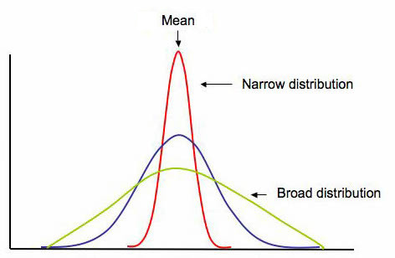  
A **spread-out** or **concentrated curve** refers to the shape and dispersion of data in a probability distribution or dataset:

* **Spread-out Curve**:
* In a **spread-out curve**, the data points are widely dispersed across the range of values, indicating **high variability**. This is usually reflected by a **high standard deviation** and **flatter curve**. The data points are less concentrated around the mean.
* Example: A **uniform distribution** or a **high-variance dataset** results in a spread-out curve.
* **Concentrated Curve**:
* In a **concentrated curve**, the data points are tightly clustered around the mean, indicating **low variability**. This is typically reflected by a **low standard deviation** and a **narrower peak** in the curve.
* Example: A **normal distribution** with a small standard deviation, where most data points are close to the mean, forms a concentrated curve.

The spread or concentration of a curve helps in understanding the **dispersion** of data, with the spread-out curve showing more diversity in the values, and the concentrated curve showing a more consistent pattern around the central value.

**Question 4**: *Can you calculate the coefficient of variation?*

**Answer**: 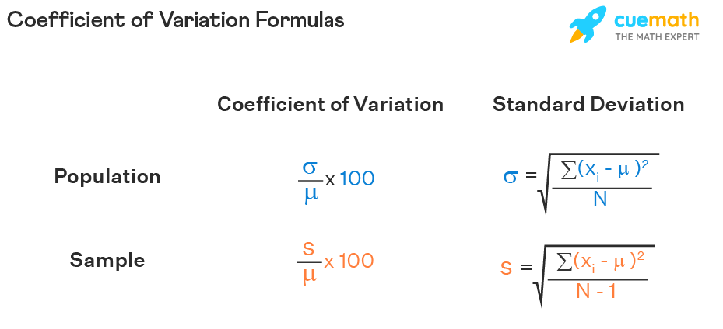  
Yes, the **Coefficient of Variation (CV)** is a measure of relative variability and is calculated as the ratio of the standard deviation to the mean, expressed as a percentage. It allows for comparison of variability across datasets with different units or scales.

* **Formula**: Coefficient of Variation (CV)=Standard DeviationMean×100\text{Coefficient of Variation (CV)} = \frac{\text{Standard Deviation}}{\text{Mean}} \times 100

**Example**:  
If a dataset has a **mean** of 50 and a **standard deviation** of 5, the coefficient of variation is:

CV=550×100=10%\text{CV} = \frac{5}{50} \times 100 = 10\%

The **CV** helps assess the **relative variability** of data, especially when comparing data with different units or magnitudes.

**Question 5**: *State the case where the median is a better measure when compared to the mean.*

**Answer**: 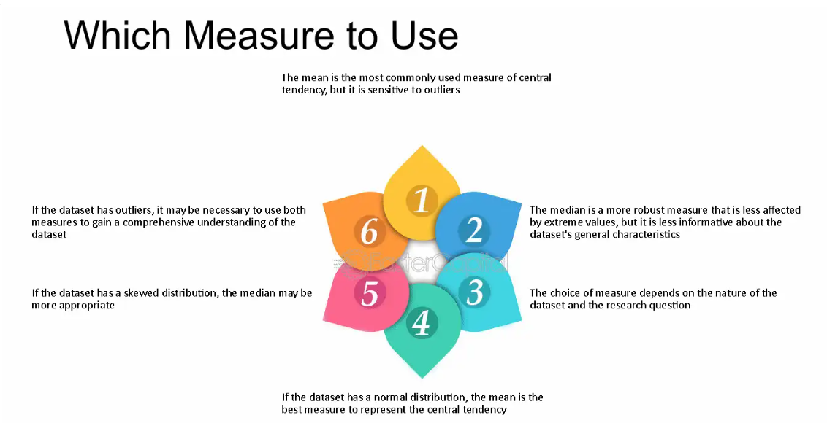  
The **median** is a better measure of central tendency than the **mean** when the data is **skewed** or contains **outliers**. This is because the median is **less sensitive** to extreme values.

For example, in a **real estate price dataset** where most houses are priced between $100,000 and $500,000, but there are a few extremely expensive houses (e.g., $10 million), the **mean** will be heavily influenced by these high values and might suggest that the typical house price is much higher than most homes in the dataset.

* **Median**: The middle value of the dataset (50th percentile) will remain closer to the majority of houses, giving a more representative value for the typical house price.
* **Mean**: Will be distorted due to the presence of extreme values (outliers).

Thus, the **median** is often preferred when dealing with **skewed distributions** or **data with outliers**.

**Question 1**: *How is missing data handled in statistics?*

**Answer**:  
Missing data can be handled in various ways, depending on the nature of the missingness and the type of analysis being performed. Here are some common methods:

* **Deletion Methods**:
* **Listwise Deletion**: Remove entire rows with missing values. This is simple but may lead to loss of valuable data, especially if the missingness is widespread.
* **Pairwise Deletion**: Only removes data for a specific analysis or pair of variables when data is missing for that pair. It retains more data but may lead to inconsistencies in analyses across variables.
* **Imputation Methods**:
* **Mean/Median/Mode Imputation**: Replace missing values with the mean (for numerical data), median (for skewed distributions), or mode (for categorical data).
* **Regression Imputation**: Use regression models to predict missing values based on other variables.
* **K-Nearest Neighbors (KNN) Imputation**: Use the values of the nearest neighbors to impute missing data.
* **Multiple Imputation**: Create multiple versions of the dataset with imputed values, analyze them separately, and then combine results to account for uncertainty.
* **Advanced Techniques**:
* **Expectation-Maximization (EM)**: An iterative process to estimate missing data based on the observed data.
* **Machine Learning Models**: Train models to predict missing values based on patterns in the data.

The choice of method depends on the amount of missing data, its pattern (random or systematic), and the importance of maintaining dataset integrity.

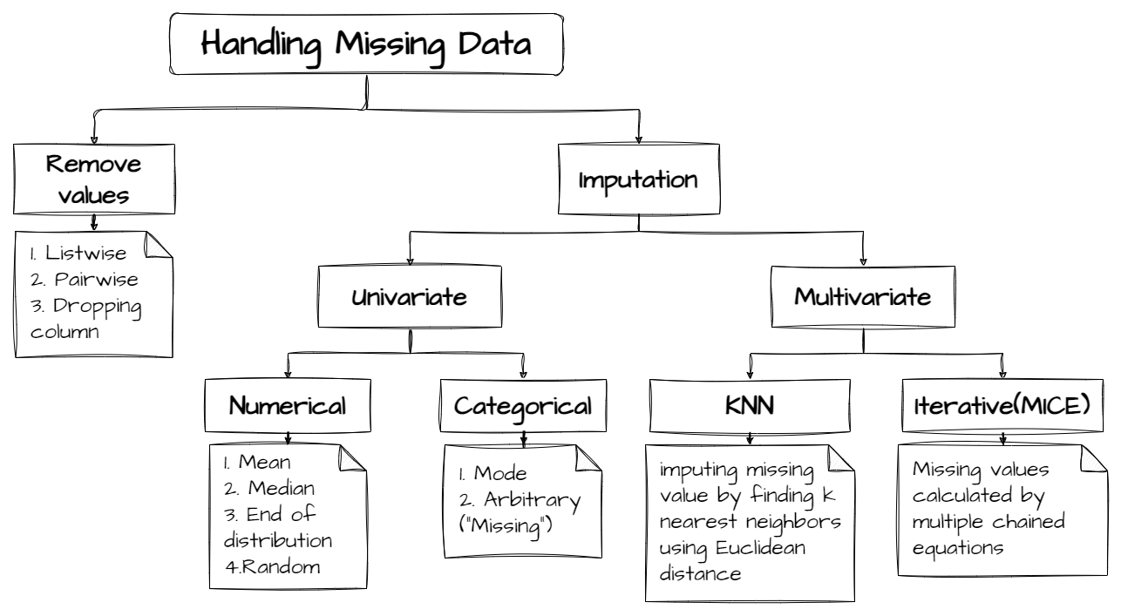

**Question 2**: *What is meant by mean imputation for missing data? Why is it bad?*

**Answer**:

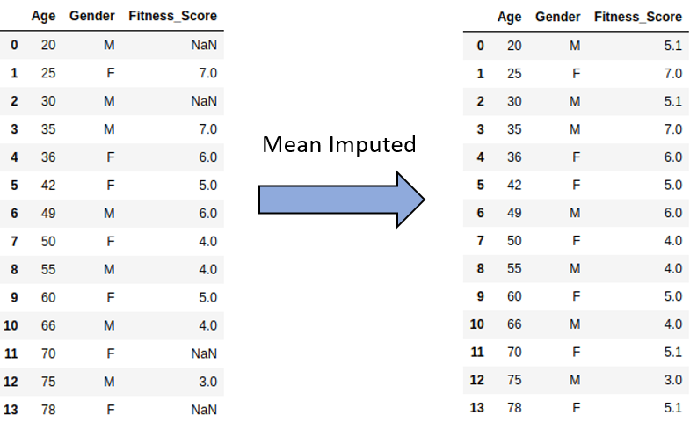  
**Mean imputation** is a technique where missing data is replaced with the **mean** value of the observed data for that variable. For example, if some values of a dataset are missing, the missing entries are filled with the average value of the available data for that variable.

**Why it’s bad**:

* **Reduces Variability**: Replacing missing values with the mean reduces the natural variability in the data, making the dataset less representative of the true population.
* **Bias in the Analysis**: Mean imputation assumes that the missing data is randomly distributed, which may not be the case. If the missing data has a systematic pattern, imputation can introduce bias.
* **Underestimates Variance**: By replacing missing values with the mean, the dataset ends up with an artificially lower variance. This can distort conclusions, especially in statistical models that rely on variability, like regression analysis.
* **Disturbs Relationships**: If missing values occur across multiple variables, mean imputation could disturb the relationships between those variables, leading to misleading or incorrect results.

**Question 3**: *What is the benefit of using box plots?*

**Answer**:  
**Box plots** (also known as **box-and-whisker plots**) are a valuable tool for visualizing the distribution of data and identifying potential outliers. The key benefits of using box plots include:

* **Identifying Central Tendency**: The box represents the interquartile range (IQR), and the line inside the box shows the **median**, providing a clear view of the data’s central value.
* **Visualizing Spread**: The length of the box represents the **IQR**, and the whiskers show the range of data, helping to understand data dispersion.
* **Detecting Outliers**: Data points that fall outside the whiskers are marked as outliers, making it easy to spot extreme values.
* **Comparing Distributions**: Box plots allow easy comparison of the distribution of multiple datasets side by side, providing insights into differences in spread, central tendency, and variability.
* **Summary of Distribution**: Box plots give a quick summary of the minimum, first quartile (Q1), median (Q2), third quartile (Q3), and maximum, which are key aspects of the **five-number summary**.

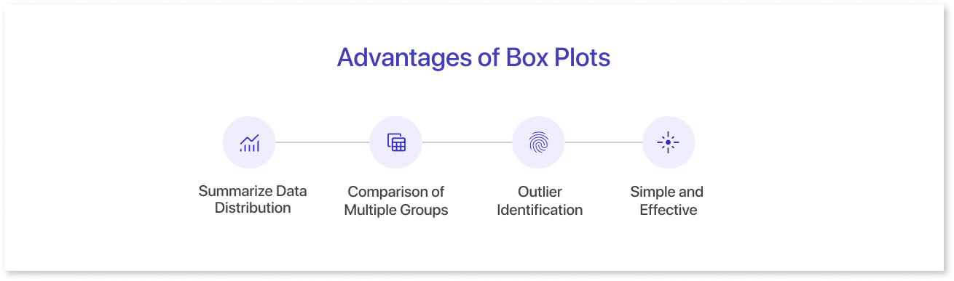

**Question 4**: *What is the meaning of the five-number summary in Statistics?*

**Answer**:  
The **five-number summary** is a set of descriptive statistics that provides a quick summary of the distribution of a dataset. It consists of:

* **Minimum**: The smallest value in the dataset.
* **First Quartile (Q1)**: The median of the lower half of the data, which is the 25th percentile.
* **Median (Q2)**: The middle value of the dataset, representing the 50th percentile.
* **Third Quartile (Q3)**: The median of the upper half of the data, representing the 75th percentile.
* **Maximum**: The largest value in the dataset.
* 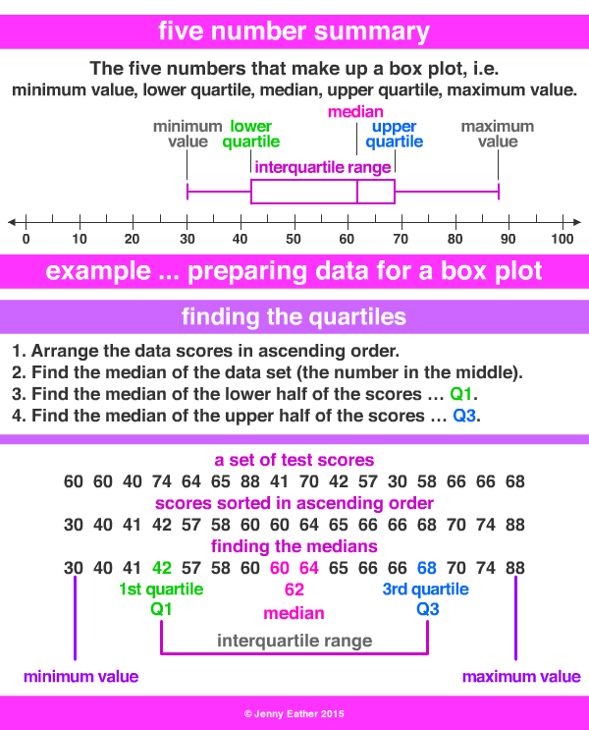

These five values give a clear understanding of the data’s spread, central tendency, and variability, and are often used to create **box plots**.

**Question 5**: *What is the difference between the First quartile, the Second quartile, and the Third quartile?*

**Answer**:  
The **quartiles** divide the dataset into four equal parts, and they help describe the spread and central tendency of the data:

* **First Quartile (Q1)**:
* Also known as the **lower quartile**, it is the value below which 25% of the data points lie. It is the **median of the lower half** of the dataset.
* **Second Quartile (Q2)**:
* This is the **median** of the entire dataset, dividing the data into two equal halves. It represents the **50th percentile** of the data.
* **Third Quartile (Q3)**:
* Also known as the **upper quartile**, it is the value below which 75% of the data points lie. It is the **median of the upper half** of the dataset.

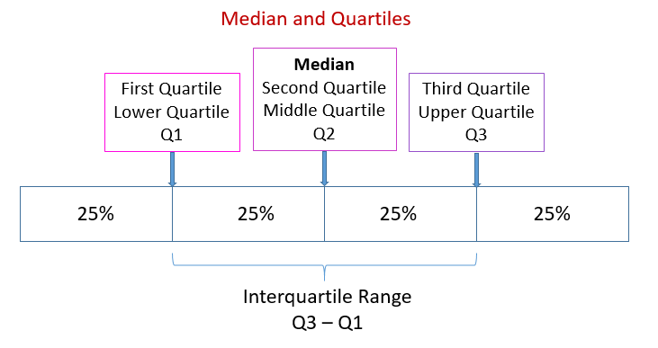

Together, Q1, Q2, and Q3 provide a comprehensive summary of the data's distribution, with the **interquartile range (IQR)** (Q3 - Q1) serving as a measure of spread or variability.

**Question 1**: *What is the difference between percent and percentile?*

**Answer**: 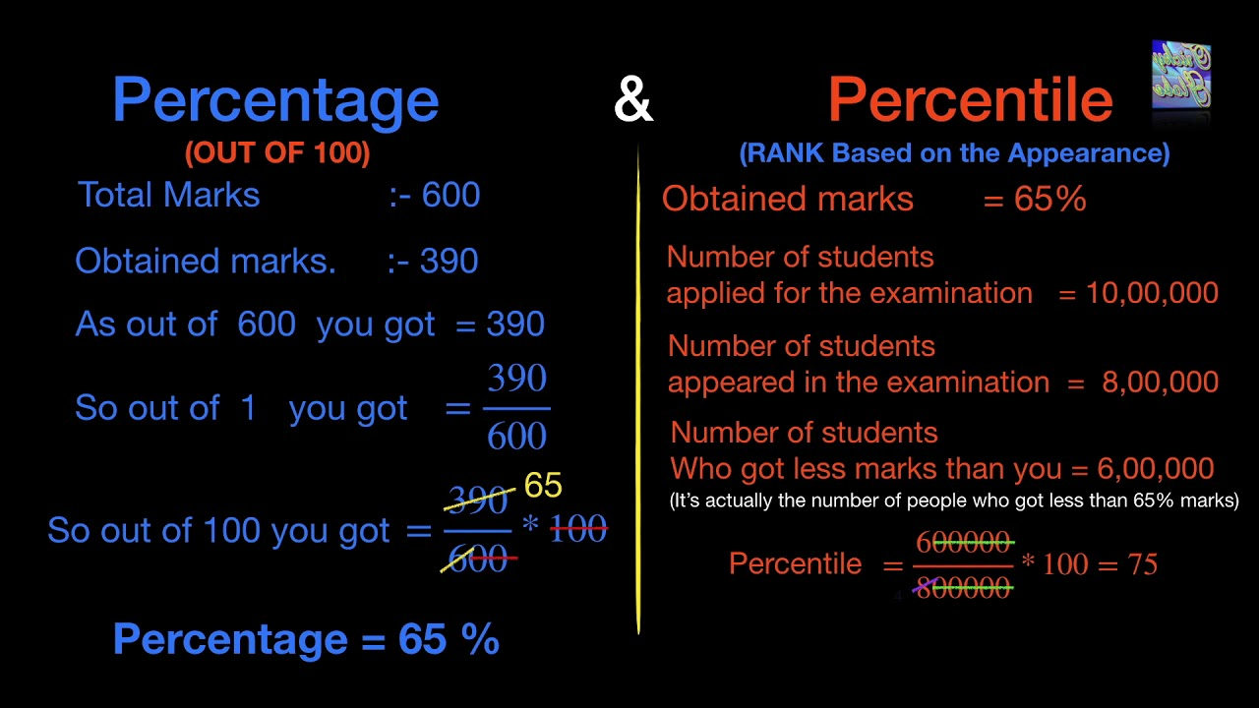

* **Percent**: A **percent** represents a fraction or portion of 100, typically used to express proportions or comparisons between two quantities. It is calculated as:

Percent=(PartWhole)×100\text{Percent} = \left( \frac{\text{Part}}{\text{Whole}} \right) \times 100

For example, if you scored 85 out of 100 on a test, your percentage score would be 85%.

* **Percentile**: A **percentile** is a value below which a given percentage of observations fall. It is used to understand the relative standing of a data point in a dataset. For example, the 90th percentile represents the value below which 90% of the data points fall. Percentiles are especially useful for understanding the distribution of data and comparing individual values against the entire dataset.

**Question 2**: *What is an Outlier?*

**Answer**:  
An **outlier** is an observation or data point that significantly differs from the rest of the data in a dataset. It is either much larger or much smaller than most other values and can indicate variability, errors, or anomalies in the data. Outliers can arise due to errors in data collection, variability in the data, or genuine rare events. Identifying and addressing outliers is important for accurate data analysis and model building.



For example, in a dataset of test scores where most students score between 50 and 90, a score of 20 or 100 might be considered an outlier.

**Question 3**: *What is the impact of outliers in a dataset?*

**Answer**:  
Outliers can have a significant impact on the analysis and results of a dataset:

* **Skewed Summary Statistics**: Outliers can skew measures of central tendency (mean) and dispersion (standard deviation, variance), leading to misinterpretation of the data. For example, a few extremely high values can inflate the mean, making it less representative of the majority of data points.
* **Distortion of Relationships**: Outliers can distort relationships in regression models or correlation analysis, leading to misleading conclusions about relationships between variables.
* **Influence on Assumptions**: Outliers can violate statistical assumptions like normality, homoscedasticity (equal variance), and linearity, which are crucial for many parametric tests.
* **Model Performance**: Outliers can affect the performance of machine learning models, especially those sensitive to extreme values (e.g., linear regression, k-nearest neighbors), causing the model to overfit or underfit the data.

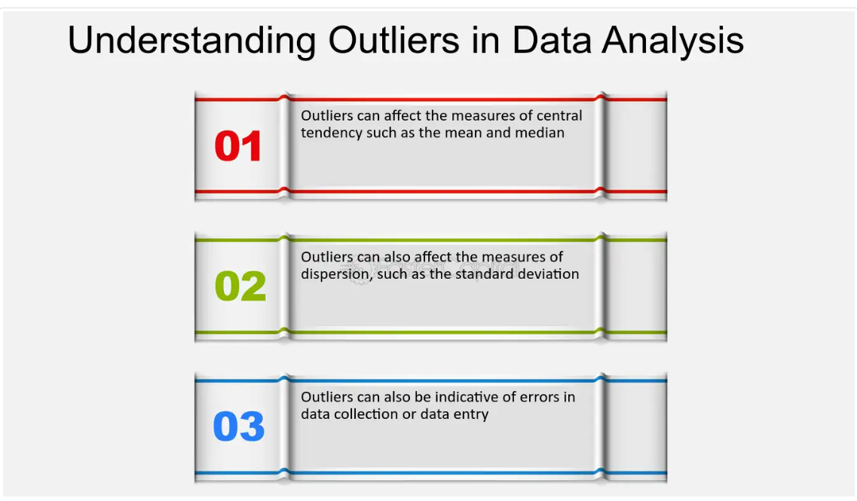

In summary, outliers can affect the reliability and accuracy of statistical analyses, and it is important to identify and decide whether to remove or adjust them.

**Question 4**: *Mention methods to screen for outliers in a dataset.*

**Answer**:  
There are several methods to **screen for outliers** in a dataset:

* **Box Plot**:
* A **box plot** visually identifies outliers by displaying the interquartile range (IQR) and marking any points outside 1.5 times the IQR from the lower (Q1) and upper (Q3) quartiles as potential outliers.
* **Z-Score**:
* The **z-score** measures how many standard deviations a data point is away from the mean. A z-score greater than 3 (or less than -3) typically indicates an outlier.
* **Formula**: z=x−μσz = \frac{x - \mu}{\sigma} where xx is the data point, μ\mu is the mean, and σ\sigma is the standard deviation.

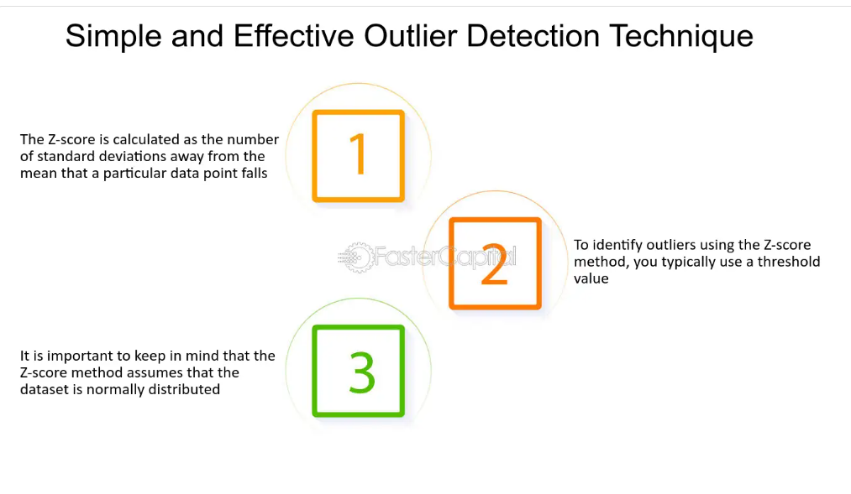

* **IQR Method**:
* **Interquartile Range (IQR)**: Outliers can be identified by looking for data points that lie outside the range of Q1−1.5×IQRQ1 - 1.5 \times \text{IQR} to Q3+1.5×IQRQ3 + 1.5 \times \text{IQR}. Any values outside this range are considered outliers.

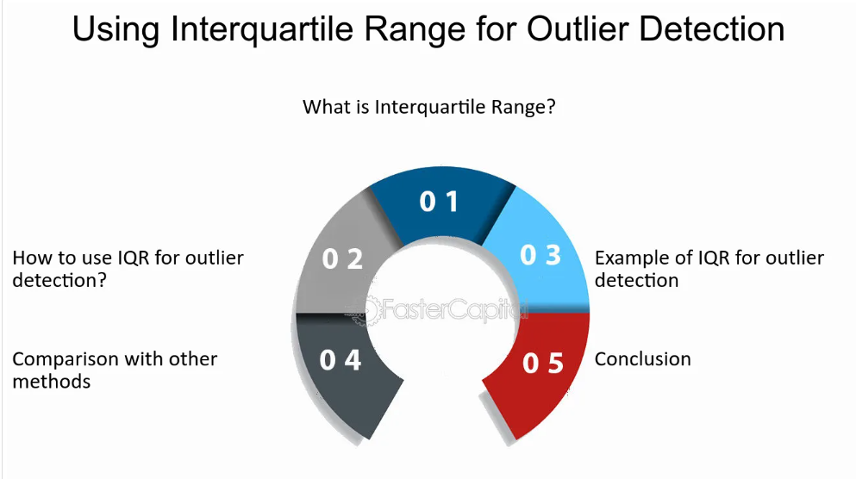

* **Visual Methods**:
* **Scatter Plots**: Visualizing data using scatter plots can help identify extreme values that deviate significantly from the rest of the data.
* **Histogram**: A histogram helps identify whether any values fall outside the expected range, signaling outliers.
* **Mahalanobis Distance**:
* This is a multivariate method to detect outliers in datasets with more than one variable. It measures how far away a data point is from the mean in terms of the covariance of the dataset.

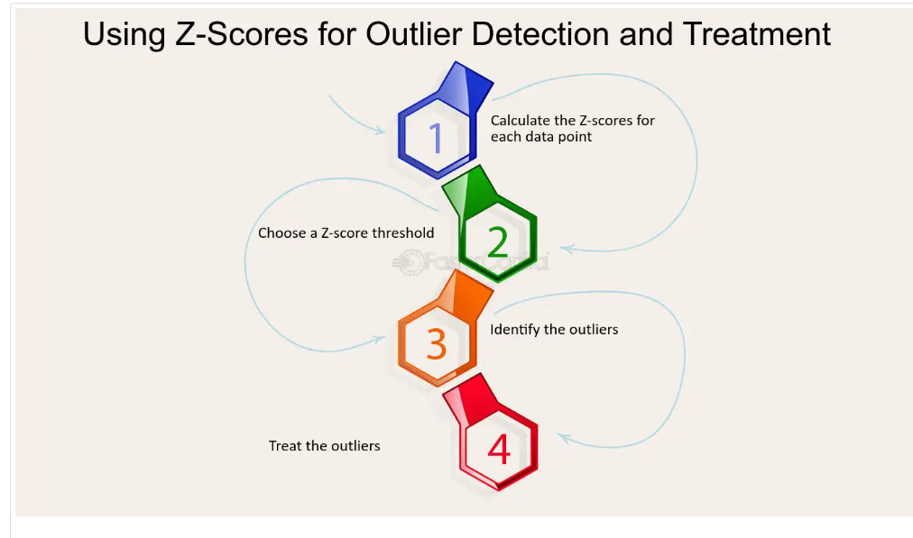

**Question 5**: *How can you handle outliers in the datasets?*

**Answer**:  
There are several approaches to handle **outliers** in a dataset, depending on the nature of the data and the analysis goals:

* **Remove Outliers**:
* If the outliers are determined to be errors or irrelevant to the analysis, they can be removed. However, this should be done carefully, especially if the outliers represent important rare events.
* **Transformation**:
* **Log Transformation**: If data is heavily skewed due to outliers, applying a log transformation (or other transformations like square root or cube root) can reduce the impact of extreme values and make the data more normally distributed.
* **Capping or Winsorizing**:
* Outliers can be capped to a certain value, such as the **95th percentile** or **5th percentile**, to limit their impact. This approach adjusts extreme values to a more reasonable range without removing them entirely.
* **Imputation**:
* If outliers are thought to represent missing or incorrect values, they can be replaced with the mean, median, or another appropriate value. However, this should be done carefully to avoid introducing bias.
* **Robust Methods**:
* Use **robust statistical methods** that are less sensitive to outliers, such as **median** instead of mean, **robust regression**, or **random forests** in machine learning, which can handle outliers more effectively.
* **Segmentation**:
* In some cases, it may be useful to segment the data into groups and treat outliers in specific segments differently, especially if the outliers represent distinct categories or groups.

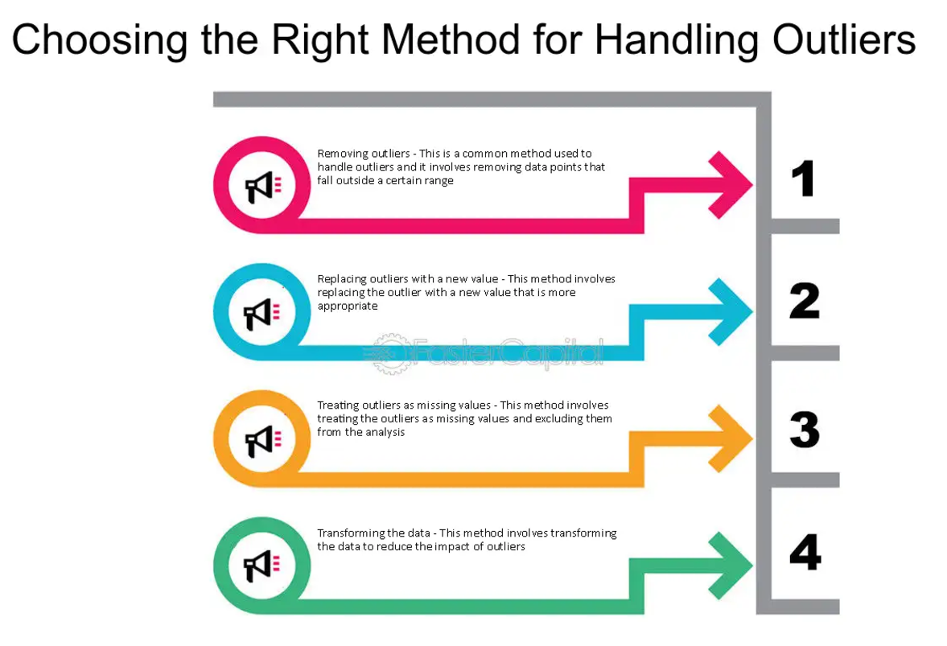

The method chosen depends on whether the outliers are valid, their impact on analysis, and the goals of the analysis. It’s important to understand the context of the outliers before deciding on how to handle them.

**Question 1**: *What is the empirical rule?*

**Answer**:  
The **empirical rule**, also known as the **68-95-99.7 rule**, is a statistical rule that applies to **normal distributions** (bell-shaped curve). It states that:

* **68% of the data** falls within one standard deviation (σ\sigma) of the mean (μ\mu).
* **95% of the data** falls within two standard deviations (2σ2\sigma) of the mean.
* **99.7% of the data** falls within three standard deviations (3σ3\sigma) of the mean.

This rule provides a quick way to understand the spread of data in a normal distribution and can be used to detect potential outliers.

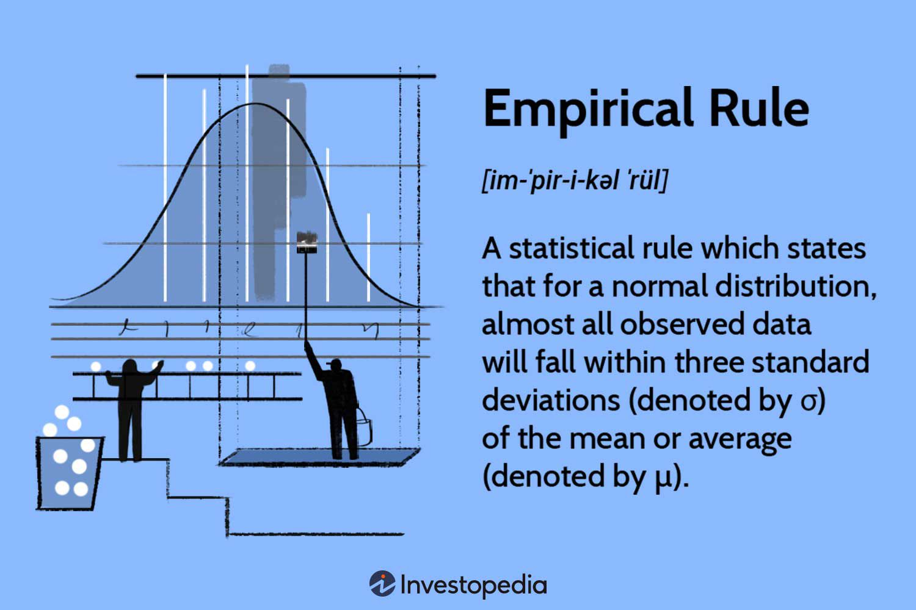

**Example**:  
If the mean height of a population is 170 cm with a standard deviation of 10 cm:

* 68% of people will have heights between 160 cm and 180 cm.
* 95% of people will have heights between 150 cm and 190 cm.
* 99.7% of people will have heights between 140 cm and 200 cm.

**Question 2**: *How to calculate range and interquartile range?*

**Answer**:

* **Range**:  
  The **range** is a measure of the spread of the data and is calculated as the difference between the **maximum** and **minimum** values in the dataset.

Range=Maximum Value−Minimum Value\text{Range} = \text{Maximum Value} - \text{Minimum Value}

**Example**: If the data points are [2,5,7,10][2, 5, 7, 10], the range is:

Range=10−2=8\text{Range} = 10 - 2 = 8

* **Interquartile Range (IQR)**:  
  The **IQR** measures the spread of the middle 50% of the data and is calculated as the difference between the **third quartile (Q3)** and the **first quartile (Q1)**:

IQR=Q3−Q1\text{IQR} = Q3 - Q1

* **Q1 (First Quartile)**: The median of the lower half of the dataset (25th percentile).
* **Q3 (Third Quartile)**: The median of the upper half of the dataset (75th percentile). **Example**: For the dataset [1,2,3,4,5,6,7,8,9][1, 2, 3, 4, 5, 6, 7, 8, 9]:
* Q1=3Q1 = 3, Q3=7Q3 = 7, so:

IQR=7−3=4\text{IQR} = 7 - 3 = 4

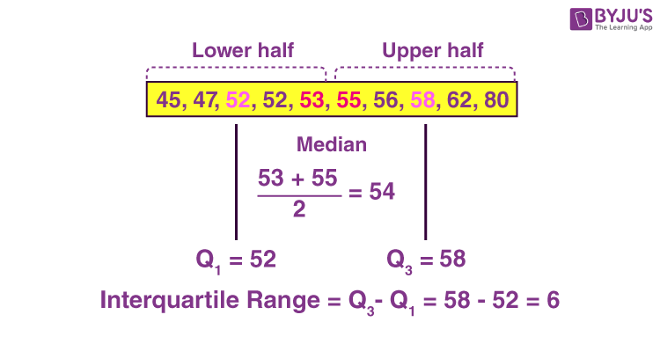

**Question 3**: *What is skewness?*

**Answer**:  
**Skewness** refers to the degree of asymmetry or departure from symmetry in a data distribution. It indicates whether the data is skewed towards the right (positively skewed) or left (negatively skewed).

* **Positive Skew (Right Skew)**: The right tail (higher values) is longer than the left tail. The mean is greater than the median.
* **Negative Skew (Left Skew)**: The left tail (lower values) is longer than the right tail. The mean is less than the median.
* **Zero Skew**: The distribution is symmetric, and the mean and median are the same (e.g., normal distribution).

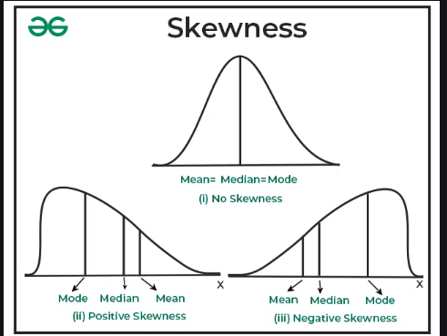

Skewness is an important indicator to understand the shape of the distribution and assess whether standard parametric tests, which assume normality, are appropriate.

**Question 4**: *What are the different measures of skewness?*

**Answer**:  
There are several ways to measure **skewness** quantitatively:

* **Pearson's First Coefficient of Skewness**:

Skewness=3(μ−Median)σ\text{Skewness} = \frac{3(\mu - \text{Median})}{\sigma}

where μ\mu is the mean, Median\text{Median} is the median, and σ\sigma is the standard deviation. This method compares the difference between the mean and median, scaled by the standard deviation.

* **Pearson's Second Coefficient of Skewness** (based on the mode):

Skewness=Mean−Modeσ\text{Skewness} = \frac{\text{Mean} - \text{Mode}}{\sigma}

This method uses the mode instead of the median.

* **Sample Skewness** (using moments): The most common method in statistics uses the third moment of the data and is calculated as:

Skewness=n(n−1)(n−2)∑(xi−xˉs)3\text{Skewness} = \frac{n}{(n-1)(n-2)} \sum \left( \frac{x_i - \bar{x}}{s} \right)^3

where xix_i is each data point, xˉ\bar{x} is the sample mean, ss is the sample standard deviation, and nn is the sample size.

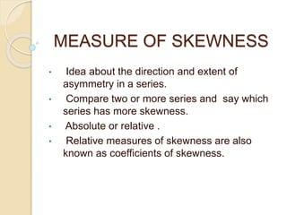

A positive skewness value indicates right skew, a negative value indicates left skew, and a value close to zero indicates a symmetric distribution.

**Question 5**: *What is kurtosis?*

**Answer**:  
**Kurtosis** is a statistical measure that describes the **tailedness** or **peakedness** of a data distribution. It indicates whether the data has heavy tails (more extreme values) or light tails (fewer extreme values) compared to a normal distribution.

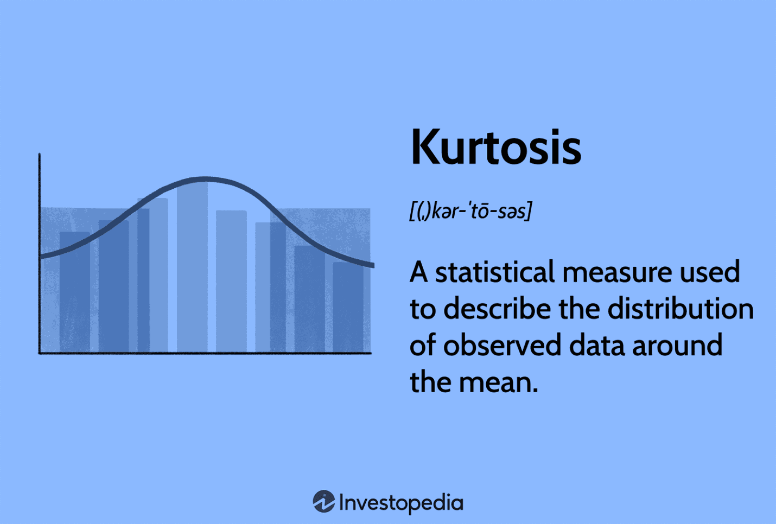

* **Leptokurtic**: A distribution with **high kurtosis**; it has a **sharp peak** and **heavy tails**. This suggests a higher frequency of extreme values (outliers).
* **Mesokurtic**: A distribution with **normal kurtosis**; it has a **normal bell curve** with tails similar to a normal distribution. The kurtosis value is close to 3 (for normal distribution).
* **Platykurtic**: A distribution with **low kurtosis**; it has a **flat peak** and **light tails**, indicating fewer outliers and a more uniform spread of data.

**Formula for Kurtosis**:  
Kurtosis is calculated using the fourth central moment:

Kurtosis=n(n+1)(n−1)(n−2)(n−3)∑(xi−xˉs)4−3(n−1)2(n−2)(n−3)\text{Kurtosis} = \frac{n(n+1)}{(n-1)(n-2)(n-3)} \sum \left( \frac{x_i - \bar{x}}{s} \right)^4 - \frac{3(n-1)^2}{(n-2)(n-3)}

where xix_i are data points, xˉ\bar{x} is the sample mean, ss is the sample standard deviation, and nn is the sample size.

* **Leptokurtic** distributions have kurtosis > 3.
* **Mesokurtic** distributions have kurtosis ≈ 3.
* **Platykurtic** distributions have kurtosis < 3.

Kurtosis helps identify the presence of **outliers** and the **concentration** of data around the mean.

**Question 1**: *Where are long-tailed distributions used?*

**Answer**:  
**Long-tailed distributions**, or **heavy-tailed distributions**, are commonly used in fields where extreme values or outliers are frequent, and the data does not follow the normal distribution. These distributions have tails that are longer than the normal distribution, meaning that extreme events (outliers) occur more frequently.

Examples of where long-tailed distributions are used include:

* **Finance**:
* In modeling financial markets, especially for returns on stocks or asset prices, **Pareto distributions** or **log-normal distributions** are often used because they capture large, rare fluctuations (e.g., stock market crashes or extreme price movements).

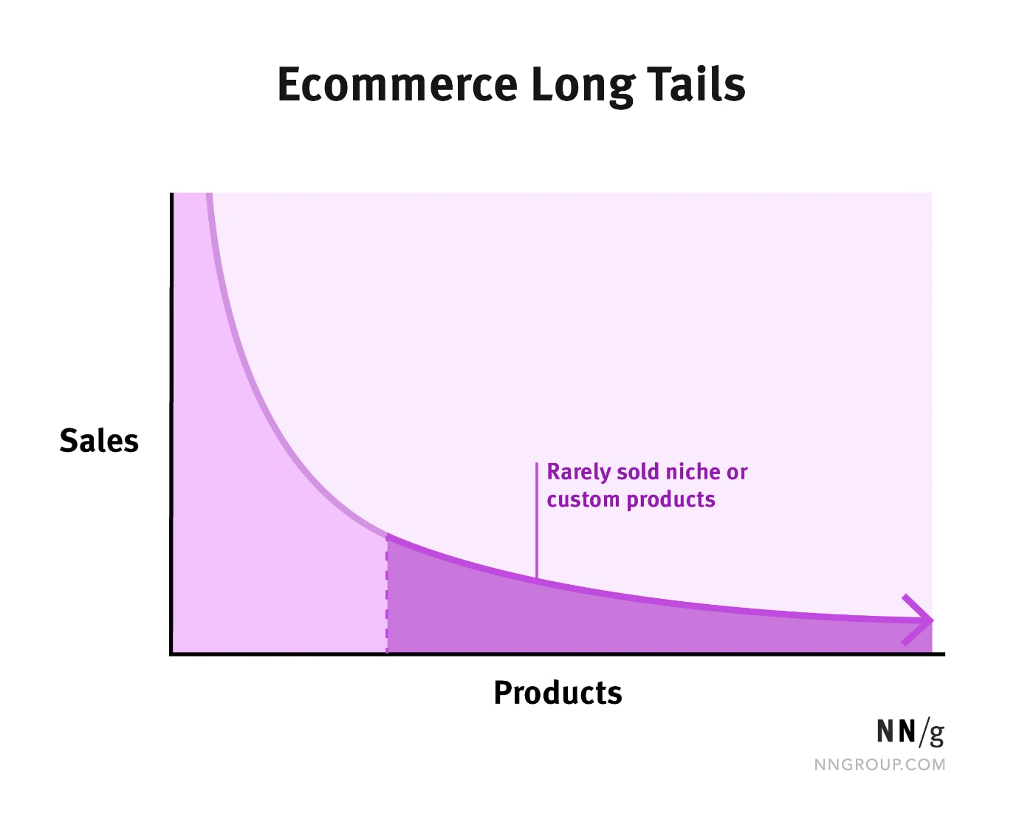

* **Insurance**:
* In **actuarial science**, long-tailed distributions are used to model rare but severe events such as natural disasters or large insurance claims.
* **Internet Traffic**:
* **Web traffic** and **data packet sizes** on networks often follow long-tailed distributions, as a few large spikes in traffic can dramatically influence the overall distribution.
* **Supply Chain & Logistics**:
* Long-tailed distributions can be used to model inventory management, where a few high-demand items may significantly impact the stock levels and restocking strategies.

**Question 2**: *What is the central limit theorem?*

**Answer**:  
The **Central Limit Theorem (CLT)** is a fundamental concept in statistics that states that the distribution of the **sample mean** (or sum) of a sufficiently large number of independent and identically distributed (i.i.d.) random variables approaches a **normal distribution**, regardless of the shape of the original distribution.

In simpler terms, if we repeatedly sample from any population and calculate the mean for each sample, the distribution of those sample means will approximate a normal distribution, as long as the sample size is large enough (usually n≥30n \geq 30).

The central limit theorem is critical because it allows us to use the normal distribution to make inferences about population parameters, even when the underlying data does not follow a normal distribution.

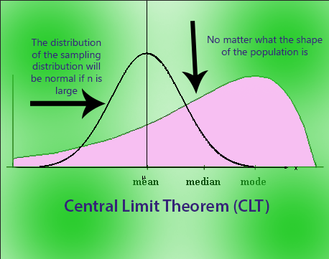

**Question 3**: *Can you give an example to denote the working of the central limit theorem?*

**Answer**:  
Let's consider an example using dice rolls:

* Imagine you roll a fair 6-sided die. The outcomes are discrete with a uniform distribution, and the average of many rolls does not follow a normal distribution.
* However, if you roll the die repeatedly and calculate the **mean of the rolls** for each set of rolls (let’s say each set contains 30 rolls), the **distribution of the sample means** (i.e., the means of all sets) will begin to approximate a **normal distribution** as the number of sets increases, even though the original distribution of a single die roll is uniform.
* This happens because of the **Central Limit Theorem**: For sufficiently large sample sizes (e.g., 30 rolls per set), the sample means will converge to a normal distribution with a mean equal to the population mean (3.5 for a fair 6-sided die) and a standard deviation that depends on the sample size.

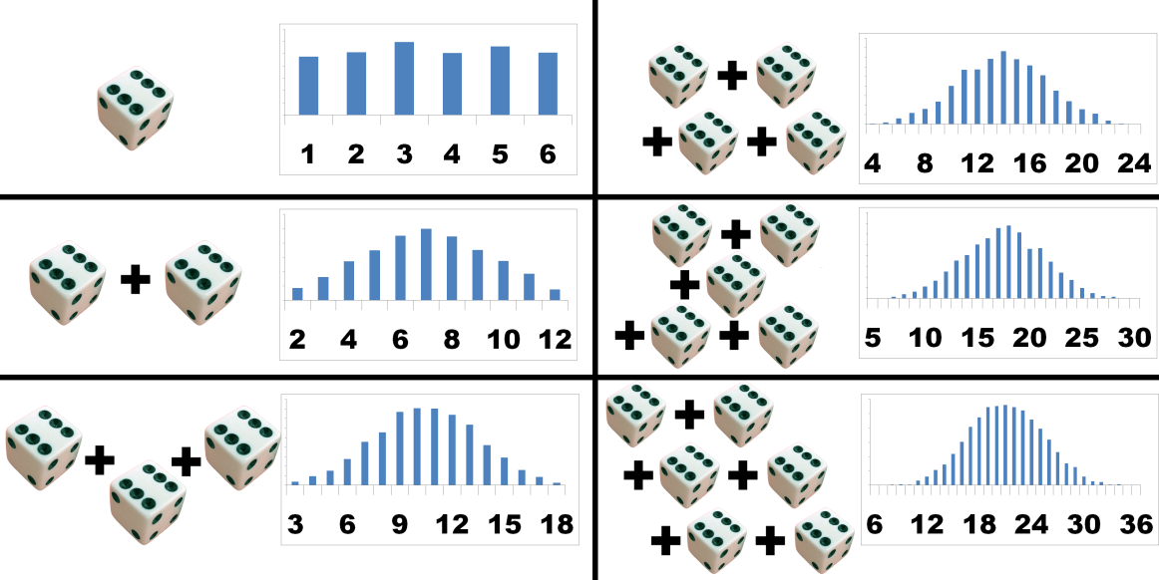

**Question 4**: *What general conditions must be satisfied for the central limit theorem to hold?*

**Answer**:  
For the **Central Limit Theorem (CLT)** to hold, the following general conditions should be satisfied:

* **The data must be sampled randomly**:
* The samples should be randomly selected from the population to avoid bias. Random sampling ensures that each individual has an equal chance of being selected and that the sample is representative of the population.
* **The sample values must be independent of each other**:
* The values in each sample must be independent. This means that the outcome of one observation should not influence the outcome of another. For example, if sampling from a population, sampling with replacement or ensuring a large enough population can help maintain independence.
* **The sample size must be sufficiently large**:
* The sample size must be large enough to approximate a normal distribution. A general rule is that the sample size should be at least 30 (n≥30n \geq 30). However, for distributions that are heavily skewed, larger sample sizes may be required to achieve normality.

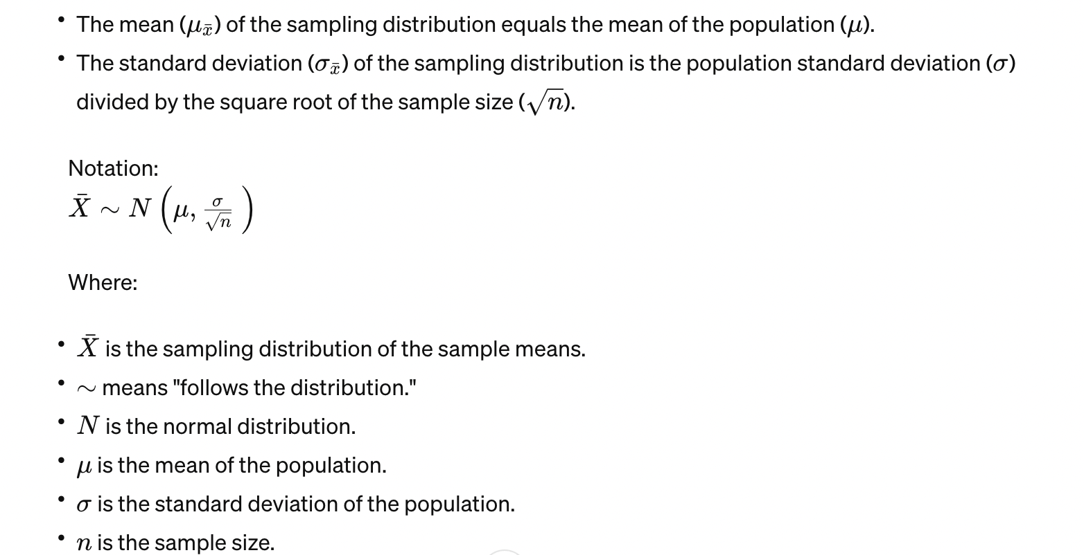

When these conditions are met, the **sampling distribution of the sample mean** will tend to be normally distributed as the sample size increases, no matter the shape of the original data distribution.

**Question 5**: *What is the meaning of selection bias?*

**Answer**:  
 **Selection bias** occurs when the sample used for analysis is not representative of the population, leading to incorrect or biased conclusions. This bias can arise when certain individuals or groups are systematically more likely to be included in the sample than others, which distorts the results.

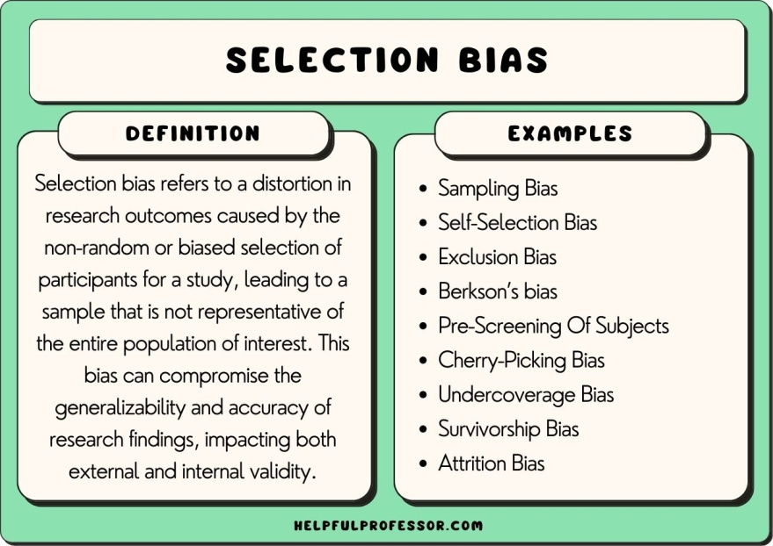

Selection bias can occur in various ways, including:

* **Non-random sampling**:
* If participants are selected in a non-random way, such as choosing participants based on certain characteristics, the sample may not accurately reflect the population.
* **Exclusion bias**:
* If certain groups are excluded from the sample, such as people who do not respond to surveys or people who drop out of a study, the sample may not represent the entire population.
* **Attrition bias**:
* In longitudinal studies, if participants drop out over time and the dropouts are not random, it can lead to selection bias, as the remaining sample may differ significantly from the original group.

**Example**:  
If a study on the effectiveness of a new drug only includes participants who are healthy and do not have any other medical conditions, the results may be biased because the sample does not represent the population of people who would actually use the drug, which includes people with comorbidities.

Selection bias can lead to incorrect generalizations and invalid results, which is why it's essential to ensure that the sample is selected randomly and is representative of the population of interest.

**Question 1**: *What are the types of selection bias in statistics?*

**Answer**:  
**Selection bias** occurs when the sample is not representative of the population, leading to inaccurate or skewed conclusions. The main types of selection bias include:

* **Sampling Bias**:  
  This occurs when the sample is not randomly selected, and certain members of the population have a higher chance of being selected than others, leading to a non-representative sample.

**Example**: If a survey is conducted online, people without internet access are excluded, leading to a biased sample.

* **Non-Response Bias**:  
  This happens when individuals selected for the sample do not respond, and the non-respondents differ systematically from respondents. If the characteristics of non-respondents are different from the general population, the sample will be biased.

**Example**: If a survey about income is sent out, and people with higher incomes do not respond, the sample may underestimate average income levels.

* **Exclusion Bias**:  
  This type of bias occurs when certain individuals or groups are excluded from the analysis, either unintentionally or deliberately. The exclusions can lead to a sample that is not representative of the entire population.

**Example**: If a clinical trial excludes participants over a certain age, the results may not apply to the elderly population.

* **Survivorship Bias**:  
  This occurs when only the "surviving" cases are considered, ignoring those that have "died off" or dropped out. This can skew the results and lead to overly optimistic conclusions.

**Example**: In studying successful startups, only surviving companies are analyzed, ignoring those that failed.

* **Attrition Bias**:  
  This happens when participants drop out of a study over time. If the dropouts are not random, it can introduce bias in the results.

**Example**: In a long-term health study, if participants with poor health drop out more frequently, the remaining sample will not represent the original population.

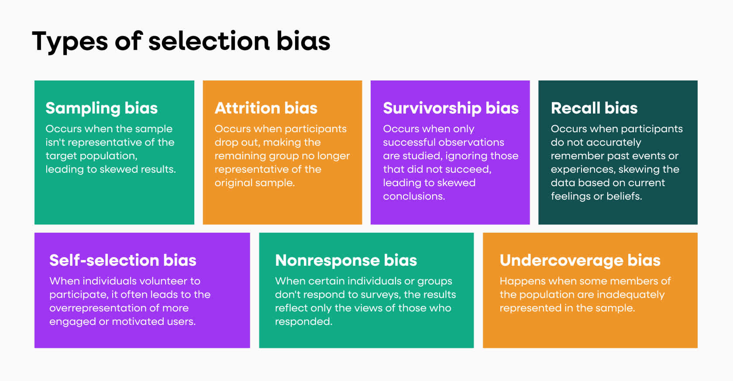

**Question 2**: *What is the probability of throwing two fair dice when the sum is 8?*

**Answer**: 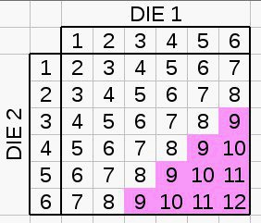  
To calculate the probability of throwing a sum of 8 with two fair dice, we first determine the number of possible outcomes and the number of favorable outcomes:

* **Total possible outcomes**:  
  When throwing two dice, each die has 6 possible outcomes, so the total number of outcomes is:

6×6=36times

* **Favorable outcomes**:  
  To get a sum of 8, the following pairs of dice rolls are possible:

(2,6),(3,5),(4,4),(5,3),(6,2)(2, 6), (3, 5), (4, 4), (5, 3), (6, 2)

There are 5 favorable outcomes.

* **Probability**:  
  The probability is the ratio of favorable outcomes to total outcomes:

P(Sum of 8)=536P(\text{Sum of 8}) = \frac{5}{36}

So, the probability of throwing a sum of 8 with two fair dice is **536\frac{5}{36}**.

**Question 3**: *What are the different types of Probability Distribution used in Data Science?*

**Answer**:  
In **Data Science**, several types of probability distributions are commonly used to model different types of data. The most popular distributions include:

* **Normal Distribution** (Gaussian Distribution):  
  A continuous probability distribution that is symmetric around the mean. It is used to model data that follows a bell-shaped curve, such as human heights or test scores.
* **Binomial Distribution**:  
  A discrete distribution used to model the number of successes in a fixed number of trials, each with a binary outcome (success or failure).

**Example**: The number of heads when flipping a coin 10 times.

* **Poisson Distribution**:  
  A discrete distribution used to model the number of events occurring in a fixed interval of time or space, given that the events happen independently.

**Example**: The number of customer arrivals at a store in an hour.

* **Exponential Distribution**:  
  A continuous distribution often used to model the time between events in a Poisson process, where events occur continuously and independently at a constant rate.

**Example**: The time between successive calls arriving at a call center.

* **Uniform Distribution**:  
  A distribution in which all outcomes are equally likely. It can be continuous or discrete.

**Example**: A fair die roll has a uniform distribution with outcomes ranging from 1 to 6.

* **Bernoulli Distribution**:  
  A discrete distribution used to model binary outcomes (0 or 1, success or failure) for a single trial.

**Example**: The outcome of a single coin toss (Heads = 1, Tails = 0).

* **Gamma Distribution**:  
  A continuous probability distribution used to model waiting times for events in a Poisson process, particularly for modeling skewed data.
* **Beta Distribution**:  
  A continuous probability distribution defined on the interval [0, 1], often used to model probabilities and proportions.
* **Log-Normal Distribution**:  
  A continuous probability distribution used when the data is positively skewed, often used to model asset returns and other financial data.
* **Chi-Square Distribution**:  
  A distribution that is widely used in hypothesis testing, particularly in tests of independence and goodness of fit.

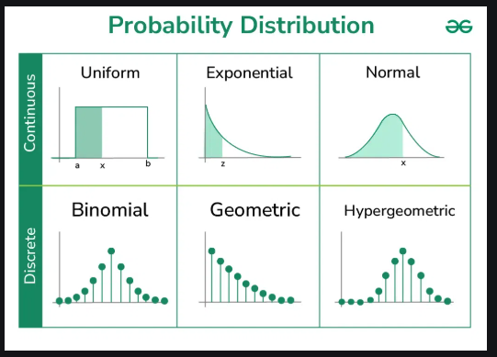

**Question 4**: *What do you understand by the term Normal Distribution or What is a bell-curve distribution?*

**Answer**:

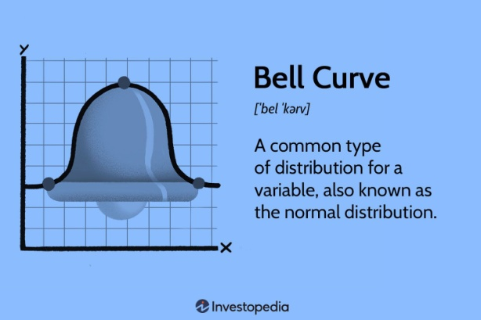  
The **Normal Distribution** (also known as the **Gaussian Distribution**) is a **continuous probability distribution** that is symmetric about the mean. The data is evenly distributed around the mean, with most of the observations clustering near the center and fewer observations appearing as we move further away from the mean. This creates the characteristic **bell-shaped curve**.

Key properties of a normal distribution:

* **Symmetry**: The curve is symmetrical around the mean, meaning the mean, median, and mode are all the same.
* **68-95-99.7 Rule**: In a normal distribution:
* **68%** of the data falls within one standard deviation of the mean. 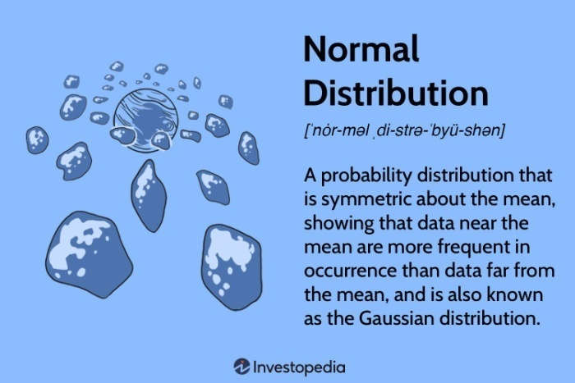
* **95%** of the data falls within two standard deviations.
* **99.7%** of the data falls within three standard deviations.
* **Tails**: The curve has asymptotic tails, meaning they approach but never touch the horizontal axis.

Normal distribution is widely used in statistical analysis because of its occurrence in various natural phenomena, such as heights, weights, test scores, and measurement errors.

**Question 5**: *Can you state the formula for normal distribution?*

**Answer**:  
The **probability density function (PDF)** for the **normal distribution** is given by the formula:

f(x)=1σ2πe−(x−μ)22σ2f(x) = \frac{1}{\sigma \sqrt{2\pi}} e^{-\frac{(x - \mu)^2}{2\sigma^2}}

Where:

* xx is the variable of interest.
* μ\mu is the **mean** of the distribution (the center of the distribution).
* σ\sigma is the **standard deviation** (a measure of the spread or dispersion of the data).
* ee is Euler's number (approximately 2.718).

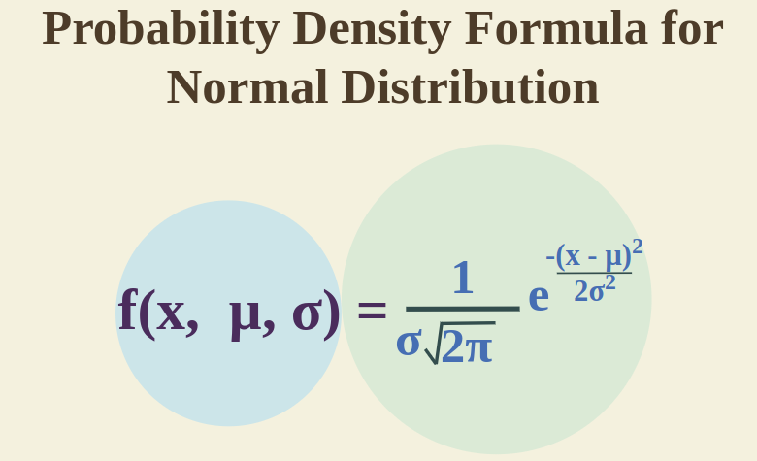

This formula describes how the data points are distributed in a normal distribution, where the likelihood of observing a value xx decreases as it moves further away from the mean. The bell curve's height is determined by the mean and standard deviation of the data.

**Question 1**: *What type of data does not have a normal distribution or a Gaussian distribution?*

**Answer**:  
Data that **does not follow a normal distribution** or **Gaussian distribution** typically exhibits certain characteristics like skewness, heavy tails, or a non-symmetrical shape. Some types of data that are unlikely to follow a normal distribution include:

* **Skewed Data**:
* Data that is **right-skewed** (positively skewed) or **left-skewed** (negatively skewed) does not follow a normal distribution. In skewed distributions, the tail on one side of the mean is longer than the other.
* Example: Income distribution often follows a right-skewed distribution, where a small number of people earn disproportionately high salaries compared to the rest.
* **Heavy-Tailed Distributions**:
* Distributions like the **Pareto distribution**, **Cauchy distribution**, and **Log-normal distribution** have heavy tails, meaning they produce more extreme values than a normal distribution.
* Example: Stock market returns often exhibit extreme fluctuations (heavy tails), making the normal distribution inappropriate.
* **Bimodal Distribution**:
* A **bimodal distribution** has two distinct peaks, unlike the single peak of a normal distribution.
* Example: Heights of people in two different populations, such as male and female populations, can result in a bimodal distribution.
* **Categorical or Discrete Data**:
* Categorical data (nominal or ordinal) or discrete data (such as the number of children in a family or number of customers arriving in an hour) do not follow a normal distribution.

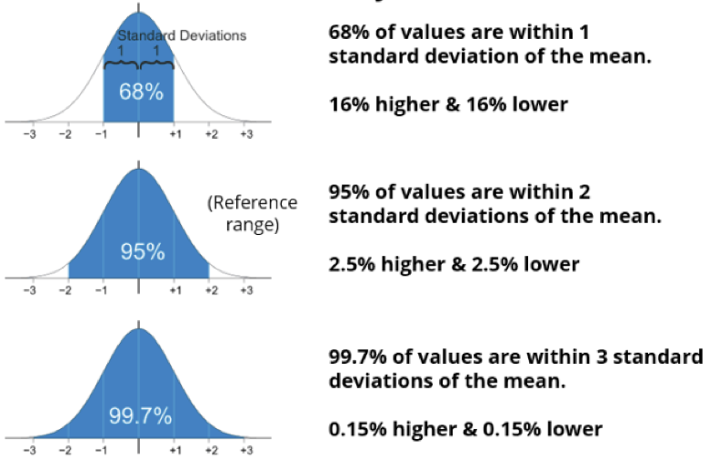

**Question 2**: *What is the relationship between mean and median in a normal distribution?*

**Answer**:  
In a **normal distribution**, the **mean** and **median** are equal and occur at the same point at the center of the distribution. This is because the normal distribution is symmetric around the mean, and the distribution's shape ensures that half of the data is below the mean and half is above the mean.

* **Mean**: The arithmetic average of all values in the distribution.
* **Median**: The middle value, such that half of the data lies below it and half lies above it.

Thus, in a perfectly normal distribution:

Mean=Median\text{Mean} = \text{Median}

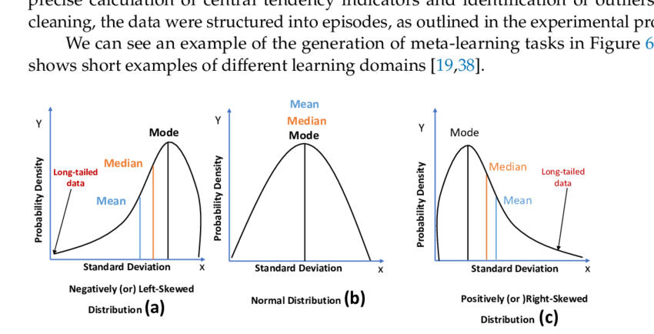

**Question 3**: *What are some of the properties of a normal distribution?*

**Answer**: 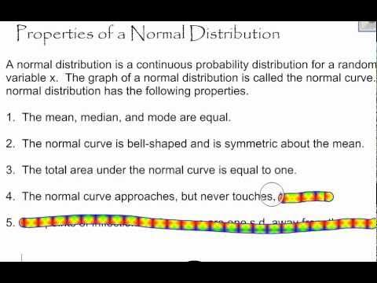  
Some of the key properties of a **normal distribution** include:

* **Symmetry**:
* The normal distribution is perfectly symmetric around the mean. This means the left and right halves of the distribution are mirror images.
* **Bell-Shaped Curve**:
* The graph of a normal distribution has a bell shape, with the highest point at the mean and tapering off towards the tails.
* **Mean, Median, and Mode**:
* In a normal distribution, the **mean**, **median**, and **mode** are all equal and located at the center of the distribution.
* **68-95-99.7 Rule**:
* **68%** of the data lies within one standard deviation (σ\sigma) from the mean.
* **95%** of the data lies within two standard deviations.
* **99.7%** of the data lies within three standard deviations.
* **Tails**:
* The tails of the normal distribution extend infinitely in both directions, but the probability of extreme values occurring in the tails is very small.
* **Asymptotic**:
* The tails of the distribution approach, but never touch, the horizontal axis, meaning the probability of observing values far from the mean is never exactly zero.

**Question 4**: *What is the assumption of normality?*

**Answer**:  
The **assumption of normality** refers to the assumption that the data follows a **normal distribution**. This assumption is critical in many statistical methods, such as hypothesis testing, confidence intervals, and regression analysis. When making this assumption, the following are typically assumed:

* **Symmetry**:  
  The data is assumed to be symmetrically distributed around the mean.
* **Bell-Shaped Distribution**:  
  The data is assumed to follow a bell-shaped, Gaussian curve, where most of the data points are close to the mean, and extreme values are less frequent.
* **Equal Variance**:  
  The data is assumed to have a constant variance (homoscedasticity) throughout the sample.

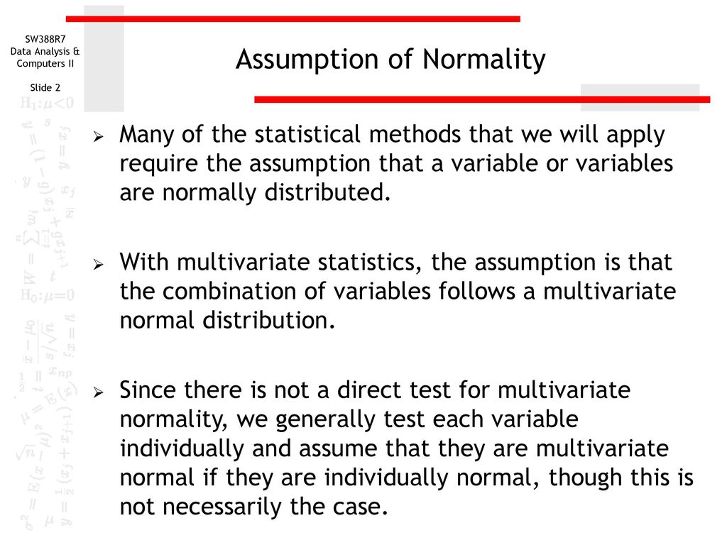

This assumption is important because if the data significantly deviates from normality, the results of statistical tests based on this assumption (like t-tests or ANOVA) may not be valid, and alternative non-parametric methods may need to be used.

**Question 5**: *How to convert normal distribution to standard normal distribution?*

**Answer**:  
To convert a **normal distribution** to a **standard normal distribution**, you need to **standardize** the data. This is done by transforming the values into **z-scores**, which represent how many standard deviations each data point is from the mean. The formula for converting a value xx from a normal distribution N(μ,σ2)N(\mu, \sigma^2) to a standard normal distribution N(0,1)N(0, 1) is:

z=x−μσz = \frac{x - \mu}{\sigma}

Where:

* zz is the **z-score** (standardized value),
* xx is the original data point,
* μ\mu is the **mean** of the original normal distribution,
* σ\sigma is the **standard deviation** of the original normal distribution.

After standardization, the data follows the **standard normal distribution**, which has:

* **Mean = 0**
* **Standard deviation = 1**

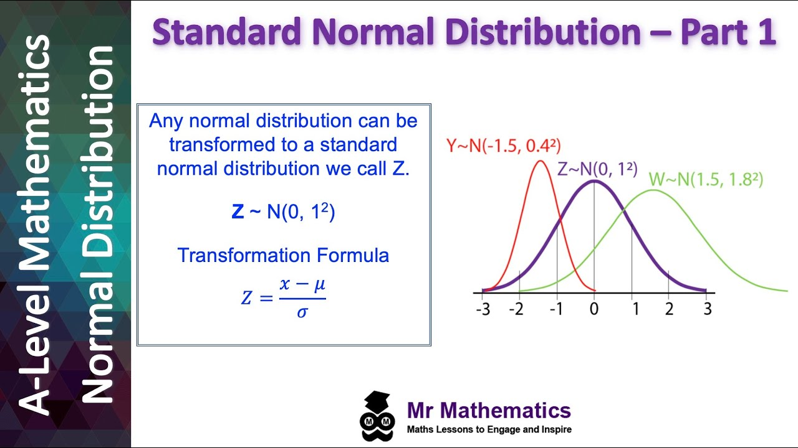

**Question 6**: *Can you tell me the range of the values in standard normal distribution?*

**Answer**:  
In a **standard normal distribution**, the range of values theoretically extends from −∞-\infty to +∞+\infty because the distribution has **asymptotic tails**. However, in practical terms, most of the values are concentrated around the mean, and the vast majority of values lie within a few standard deviations from the mean.

Specifically, for a **standard normal distribution** (mean = 0, standard deviation = 1), the range of values typically falls within the following intervals:

* **68%** of the values lie between −1-1 and +1+1 standard deviation.
* **95%** of the values lie between −2-2 and +2+2 standard deviations.
* **99.7%** of the values lie between −3-3 and +3+3 standard deviations.

Beyond 3 standard deviations, the probability of finding a value decreases exponentially, but theoretically, values can go all the way to negative and positive infinity.



**Question 7**: *What is the Pareto principle?*

**Answer**:  
The **Pareto principle**, also known as the **80/20 rule**, states that, in many situations, approximately **80% of the effects come from 20% of the causes**. This principle is named after **Vilfredo Pareto**, an Italian economist who observed that about 80% of Italy's wealth was owned by 20% of the population.

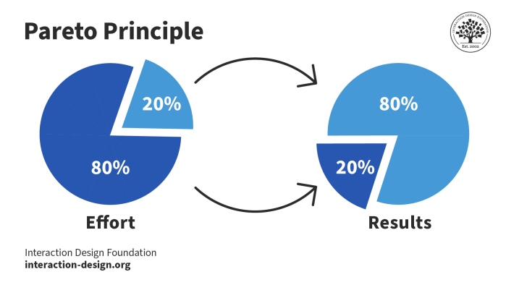

In various contexts, the Pareto principle can be applied to suggest that:

* **80% of sales** come from **20% of customers**,
* **80% of defects** come from **20% of the processes**,
* **80% of tasks** can be completed by focusing on **20% of the most important tasks**.

This rule helps in identifying the most significant factors that contribute to the majority of results, allowing for better prioritization and resource allocation.

**Question 1**: *What are left-skewed and right-skewed distributions?*

**Answer**:

* A **left-skewed** (or **negatively skewed**) distribution is one where the **left tail** (the lower end) is longer or more spread out than the **right tail**. This means that there are a smaller number of extremely low values compared to high values. For a left-skewed distribution, the **mean** is less than the **median**, and the **median** is less than the **mode**.
* **Mean < Median < Mode** in a left-skewed distribution.
* Example: Income distribution in many countries where most people earn average or above-average wages, but a few earn very low wages, pulling the mean down.

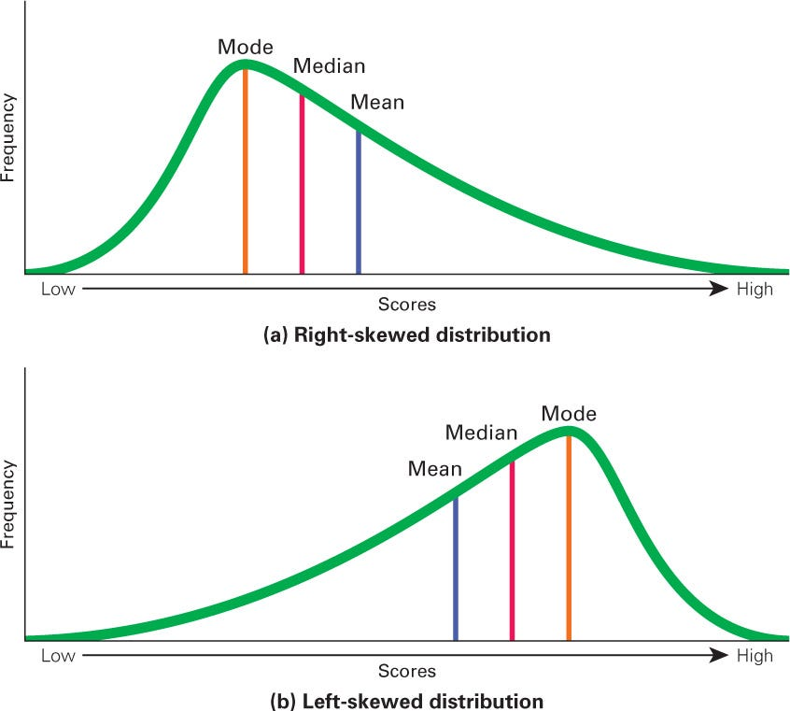

* A **right-skewed** (or **positively skewed**) distribution is one where the **right tail** (the higher end) is longer or more spread out than the **left tail**. This means that there are a smaller number of extremely high values compared to low values. For a right-skewed distribution, the **mean** is greater than the **median**, and the **median** is greater than the **mode**.
* **Mean > Median > Mode** in a right-skewed distribution.
* Example: Wealth distribution, where a small number of individuals have very high wealth, pulling the mean to the right.

**Question 2**: *If a distribution is skewed to the right and has a median of 20, will the mean be greater than or less than 20?*

**Answer**:  
If the distribution is **right-skewed**, the **mean** will be greater than the **median**. This is because, in a right-skewed distribution, the tail on the right side pulls the mean towards the higher values.

So, in this case, the **mean will be greater than 20**.

**Question 3**: *Given a left-skewed distribution that has a median of 60, what conclusions can we draw about the mean and the mode of the data?*

**Answer**:  
In a **left-skewed** (negative skew) distribution, the left tail is longer than the right tail, which means that there are a small number of lower values that pull the **mean** to the left of the **median**. The **mode**, being the peak of the distribution, will be to the right of the **median** since most of the data is concentrated toward the higher values.

Thus:

* **Mean < Median < Mode**.
* Given that the **median** is 60, the **mean** will be less than 60, and the **mode** will be greater than 60.

**Question 4**: *Imagine that Jeremy took part in an examination. The test has a mean score of 160, and it has a standard deviation of 15. If Jeremy’s z-score is 1.20, what would be his score on the test?*

**Answer**:  
To calculate Jeremy's score on the test, we use the **z-score formula**:

z=X−μσz = \frac{X - \mu}{\sigma}

Where:

* zz is the **z-score**,
* XX is the **score** Jeremy received,
* μ\mu is the **mean** score,
* σ\sigma is the **standard deviation**.

Rearranging the formula to solve for XX:

X=z×σ+μX = z \times \sigma + \mu

Substituting the values:

X=1.20×15+160=18+160=178X = 1.20 \times 15 + 160 = 18 + 160 = 178

Thus, Jeremy's score on the test would be **178**.

**Question 5**: *The standard normal curve has a total area to be under one, and it is symmetric around zero. True or False?*

**Answer**:  
**True**.  
The **standard normal distribution** is symmetric around **zero**, and the total area under the curve is **1**. This means that the probability of observing any value from the standard normal distribution is 1 (or 100%) when considering the entire range of possible values.

**Question 6**: *Briefly explain the procedure to measure the length of all sharks in the world.*

**Answer**:  
Measuring the length of **all sharks in the world** is a challenging task due to the vast number of species and individuals across different ecosystems. However, a general procedure might involve:

* **Sampling**:
* **Random Sampling**: A representative sample of sharks would need to be collected from various habitats (oceans, seas, research centers).
* **Stratified Sampling**: If there are various species or regions with significantly different shark populations, samples can be stratified accordingly.
* **Data Collection**:
* Sharks would be captured (using ethical methods) or measured in the wild using non-invasive techniques like drones, remote underwater cameras, or tagging devices.
* The **length** of each shark would be recorded using measuring tools (e.g., tape measures or laser-based measurement systems).
* **Data Aggregation**:
* After gathering data, the lengths of the sampled sharks would be aggregated and analyzed. Depending on the purpose, various statistical methods can be applied (e.g., calculating average length, range, or standard deviation).
* **Extrapolation**:
* Since it is not feasible to measure every shark, data from the sample can be used to estimate the lengths of the entire shark population using statistical techniques like **estimation** or **modeling**.

This method would provide a reasonable estimate, though it would have inherent uncertainty due to the difficulty of measuring all sharks worldwide.

**Question 1**: *Can you tell me the difference between unimodal, bimodal, and bell-shaped curves?*

**Answer**:

* **Unimodal**: A **unimodal** distribution has only **one peak**. The data is concentrated around a single central value, and it can be symmetric or skewed. An example of a unimodal distribution is the **normal distribution**.
* **Bimodal**: A **bimodal** distribution has **two peaks**, each representing a mode or most frequent value. This indicates that the data may come from two different groups or populations. An example could be the **height distribution** of male and female populations.
* **Bell-shaped**: A **bell-shaped** curve refers to the specific shape of a **normal distribution**, which is symmetric and peaks at the mean. It is unimodal and follows the **68-95-99.7 rule** for standard deviations. A bell-shaped curve can also refer to other unimodal, symmetric distributions, but it’s most commonly associated with normal distributions.

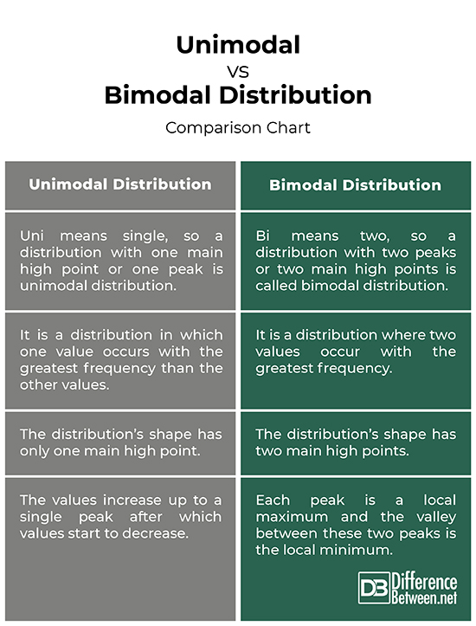

**Question 2**: *Does symmetric distribution need to be unimodal?*

**Answer**:  
Not necessarily. While **unimodal distributions** are often **symmetric**, a **symmetric distribution** does not have to be unimodal.

* A **symmetric distribution** is one where the left and right sides of the distribution are mirror images of each other. However, it is possible for a symmetric distribution to have more than one peak (i.e., be **multimodal**).
* A **unimodal distribution** is specifically a distribution with **one peak**, and it can either be symmetric (like the normal distribution) or skewed.

Thus, while all **unimodal symmetric distributions** are symmetric, **not all symmetric distributions** are unimodal (e.g., a symmetric multimodal distribution is possible).

**Question 3**: *What are some examples of data sets with non-Gaussian distributions?*

**Answer**:  
When data does not follow a normal (Gaussian) distribution, it is **non-Gaussian**. Some examples include:

* **Exponential Distribution**:
* **Bacterial Growth**: As you mentioned, bacterial growth often follows an exponential or log-normal distribution, where growth accelerates rapidly at first but slows down over time.
* **Poisson Distribution**:
* **Call Center Arrivals**: The number of calls arriving at a call center in a given period often follows a **Poisson distribution**, especially if calls are random and independent events.
* **Log-normal Distribution**:
* **Income Distribution**: Personal income distribution often follows a **log-normal distribution**, where most individuals earn relatively lower amounts, and a small percentage earn extremely high amounts.
* **Binomial Distribution**:
* If a dataset represents the number of successes in a fixed number of trials with two possible outcomes, it may follow a **binomial distribution**, which is non-Gaussian.
* **Uniform Distribution**:
* **Random Selection**: When selecting data randomly from a uniform range (e.g., rolling a fair die or randomly choosing a number between 1 and 10), the distribution is **uniform**, which is non-Gaussian.

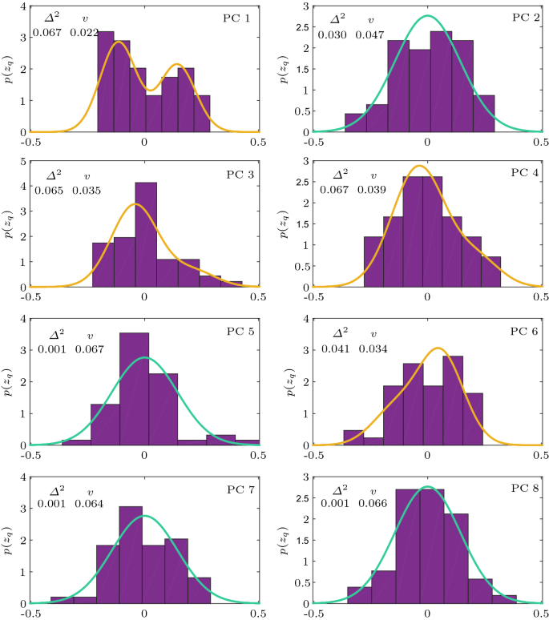

**Question 4**: *What is the Binomial Distribution Formula?*

**Answer**:  
The **Binomial Distribution** formula is used to model the number of successes in a fixed number of independent trials of a binary experiment (success/failure). The formula is:

P(X=k)=(nk)pk(1−p)n−kP(X = k) = \binom{n}{k} p^k (1-p)^{n-k}

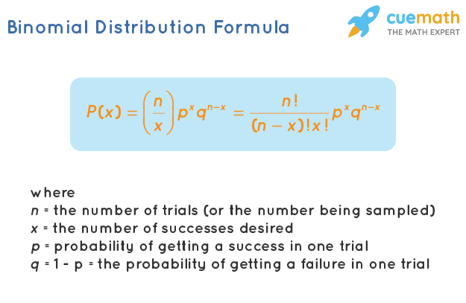

Where:

* P(X=k)P(X = k) is the probability of getting exactly kk successes,
* nn is the number of trials,
* kk is the number of successes,
* pp is the probability of success on a single trial,
* (nk)\binom{n}{k} is the **binomial coefficient** (the number of ways to choose kk successes from nn trials), and is calculated as: (nk)=n!k!(n−k)!\binom{n}{k} = \frac{n!}{k!(n-k)!}

**Question 5**: *What are the criteria that Binomial distributions must meet?*

**Answer**:  
For a distribution to be considered **binomial**, it must meet the following criteria:

* **Fixed Number of Trials**:  
  The number of trials (nn) must be fixed in advance.
* **Binary Outcomes**:  
  Each trial must have only two possible outcomes (e.g., **success** or **failure**).
* **Independent Trials**:  
  The trials must be **independent**, meaning the outcome of one trial does not affect the outcome of another.
* **Constant Probability of Success**:  
  The probability of success (pp) must be the same for every trial.

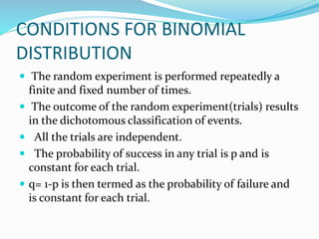

**Question 6**: *What are examples of symmetric distributions?*

**Answer**:  
Some examples of **symmetric distributions** include:

* **Normal Distribution**:
* The **normal (Gaussian) distribution** is perfectly symmetric around its mean. It is the most common symmetric distribution used in statistics.
* **Uniform Distribution**:
* The **uniform distribution** is symmetric when the probability is constant across all values within a defined range. Each outcome has the same probability of occurring.
* **T-distribution**:
* The **t-distribution** is symmetric around its mean, and it’s often used in hypothesis testing, especially for small sample sizes.
* **Laplace Distribution**:
* The **Laplace distribution**, also known as the double-exponential distribution, is symmetric around its mean and has heavier tails compared to the normal

distribution.

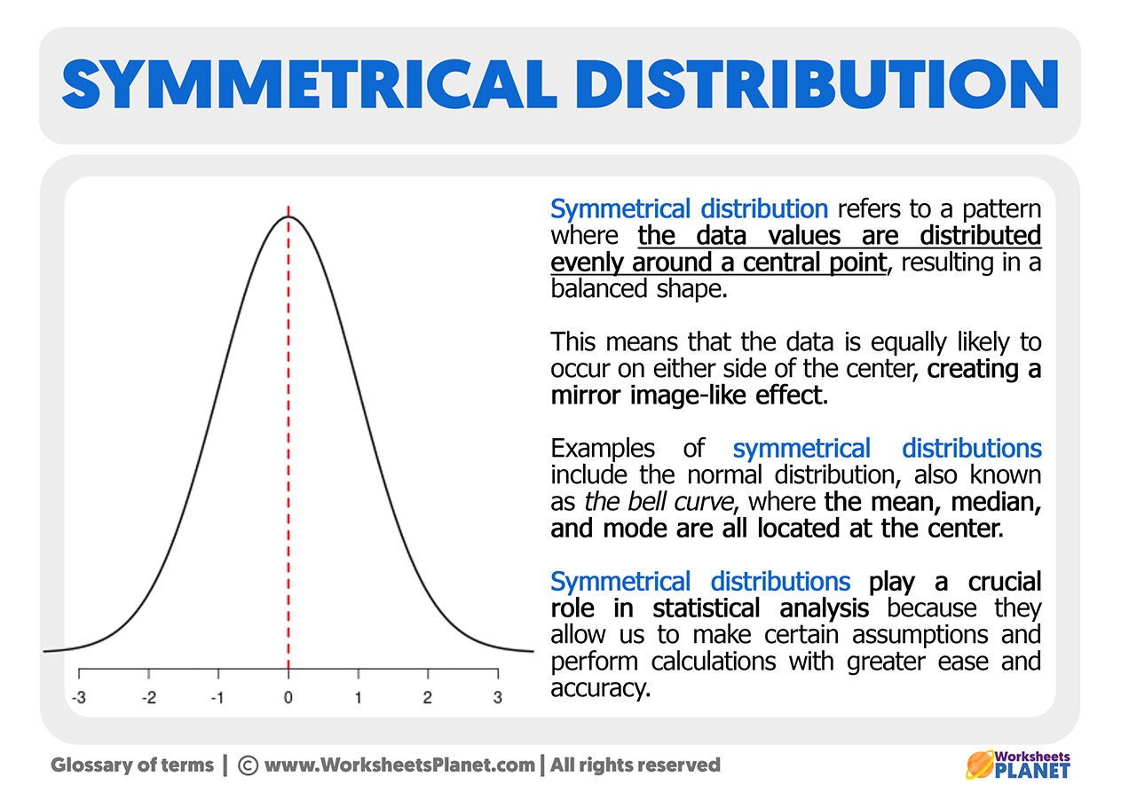

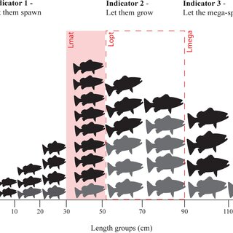**Question 7**: *How to find the mean length of all fishes in the sea?*

**Answer**:  
To estimate the **mean length of all fishes in the sea**, follow this procedure:

* **Define the Confidence Level**:
* The confidence level is the degree of certainty you want in your estimate, commonly set to **95%**.
* **Take a Sample**:
* Randomly sample a sufficient number of fishes from the sea. To get a reliable estimate, the sample size should ideally be **greater than 30**.
* **Calculate the Sample Mean and Standard Deviation**:
* For the collected sample of fishes, calculate the **mean length** and **standard deviation** of the lengths.
* **Calculate the t-Statistic**:
* Use the sample mean, sample standard deviation, and the sample size to calculate the **t-statistic**: t=Xˉ−μsnt = \frac{\bar{X} - \mu}{\frac{s}{\sqrt{n}}} where Xˉ\bar{X} is the sample mean, ss is the sample standard deviation, and nn is the sample size.
* **Compute the Confidence Interval**:
* Using the t-statistic and the sample standard deviation, calculate the **confidence interval** within which the true population mean length of all fishes should lie. The formula for the confidence interval is: μ±t×sn\mu \pm t \times \frac{s}{\sqrt{n}} where μ\mu is the sample mean, tt is the t-value corresponding to the confidence level, ss is the sample standard deviation, and nn is the sample size.

By this method, you can estimate the **mean length of all fishes** in the sea with a specified confidence level.

**Question 1**: *What are the types of sampling in Statistics?*

**Answer**: 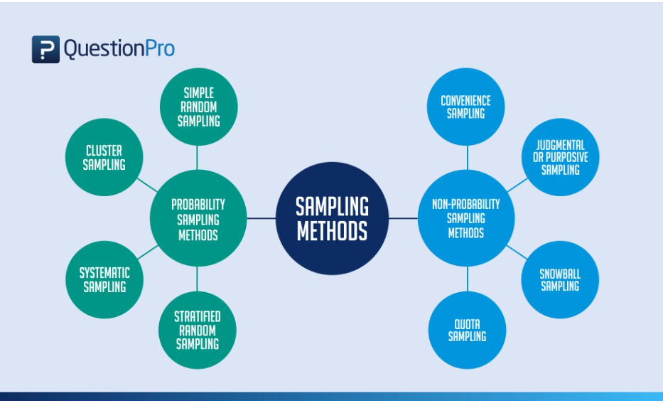

In statistics, sampling methods are used to select a subset of individuals from a larger population to make inferences about the entire population. The most common types of sampling include:

* **Simple Random Sampling (SRS)**:  
  Every individual in the population has an equal chance of being selected. This method is often done using random number generators or lottery systems.
* **Systematic Sampling**:  
  A starting point is chosen randomly, and then every kk-th individual is selected. For example, if you select every 10th person in a list.
* **Stratified Sampling**:  
  The population is divided into distinct subgroups (strata) that share a specific characteristic (e.g., age, gender, income), and a random sample is taken from each stratum.
* **Cluster Sampling**:  
  The population is divided into clusters (usually based on geographical areas or other factors), and then a random sample of clusters is selected. All individuals within selected clusters are included in the sample.
* **Convenience Sampling**:  
  The sample is taken from individuals who are easiest to reach or are readily available.
* **Judgmental or Purposive Sampling**:  
  The researcher uses their knowledge to select a sample that they believe is representative or relevant.

**Question 2**: *Why is sampling required?*

**Answer**:  
Sampling is required because it is often impractical or impossible to collect data from an entire population. Key reasons for sampling include:

* **Cost-effective**: Collecting data from an entire population can be expensive and time-consuming. Sampling allows for a smaller, more manageable data set while still providing reliable estimates.
* **Time-saving**: Gathering information from every individual in a population is often too time-consuming, especially for large populations.
* **Feasibility**: In many cases, it's physically impossible to reach every member of a population (e.g., in the case of wildlife populations).
* **Accurate Estimations**: With proper sampling techniques, it’s possible to make accurate inferences about a population with minimal error.

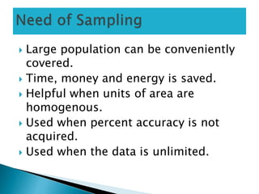

**Question 3**: *How do you calculate the needed sample size?*

**Answer**:  
To calculate the **needed sample size**, you need several factors, including the **population size**, the **desired confidence level**, the **margin of error**, and the **estimated proportion**. The formula for sample size in proportion studies is:

n=Z2×p×(1−p)E2n = \frac{Z^2 \times p \times (1-p)}{E^2}

Where: 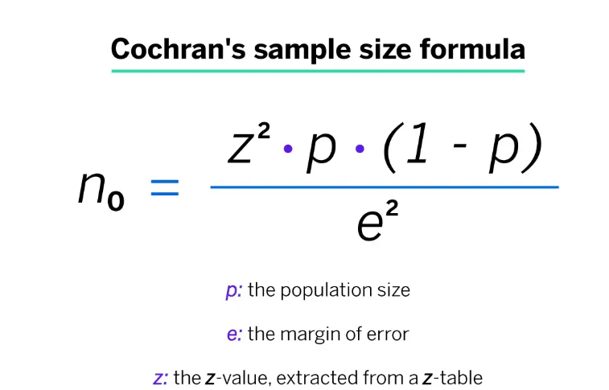

* nn = Sample size
* ZZ = Z-score (for the desired confidence level, e.g., 1.96 for 95% confidence)
* pp = Estimated proportion (probability of success, if unknown, use 0.5 for maximum variance)
* EE = Desired margin of error (expressed as a decimal, e.g., 0.05 for a 5% margin)

For a **finite population**, the formula adjusts to account for the population size:

n=N×n0N+n0−1n = \frac{N \times n_0}{N + n_0 - 1}

Where:

* n0n_0 is the sample size from the previous formula,
* NN is the population size.

**Question 4**: *Can you give the difference between stratified sampling and clustering sampling?*

**Answer**:

* **Stratified Sampling**:
* Involves dividing the population into **distinct subgroups (strata)** based on a specific characteristic (e.g., gender, income, age).
* A **random sample** is then selected from each stratum.
* It ensures that each subgroup is proportionally represented in the sample, which increases precision.
* **Cluster Sampling**:
* The population is divided into **clusters** (usually based on location or other logical groupings).
* Entire clusters are then selected randomly, and all individuals in the selected clusters are surveyed.
* It’s more cost-effective but may introduce more variability if clusters are not representative of the whole population.

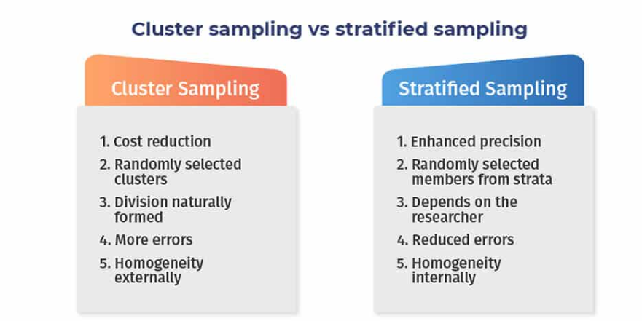

**Question 5**: *Where is inferential statistics used?*

**Answer**:  
**Inferential statistics** is used to make predictions or inferences about a population based on a sample of data. It is typically used in:

* **Hypothesis Testing**:  
  To test assumptions or claims about a population (e.g., whether the mean income of a population is greater than $50,000).
* **Estimation**:  
  To estimate population parameters (e.g., estimating the mean height of all students in a school based on a sample).

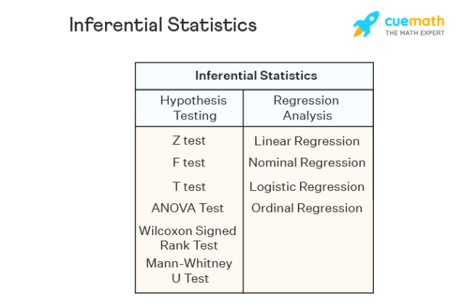

* **Predictive Analysis**:  
  To make predictions about future events or unknown values (e.g., predicting election outcomes based on sample polls).
* **Making Generalizations**:  
  When it is not feasible to gather data from an entire population, inferential statistics allows for generalizations based on sample data.

**Question 6**: *What are population and sample in Inferential Statistics, and how are they different?*

**Answer**:

* **Population**:  
  The **population** is the entire group of individuals or items that you want to make inferences about. It includes all possible data points or observations.
* Example: All the voters in a country, all students in a school, or all products manufactured in a factory.
* **Sample**:  
  A **sample** is a **subset** of the population selected for analysis. The sample is used to make inferences about the population, but it should be representative to avoid bias.
* Example: A random selection of 100 voters from the country or a sample of 50 students from the school.

**Difference**:

* A **population** is the whole group, while a **sample** is a smaller, manageable part of the population. The goal of inferential statistics is to use the sample to make reliable conclusions about the population.

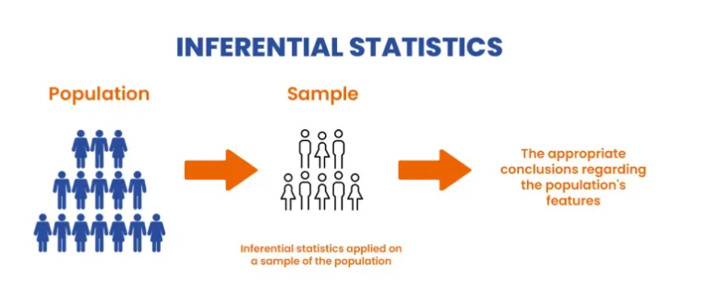

**Question 7**: *What is the relationship between the confidence level and the significance level in statistics?*

**Answer**:  
The **confidence level** and the **significance level** are complementary to each other: 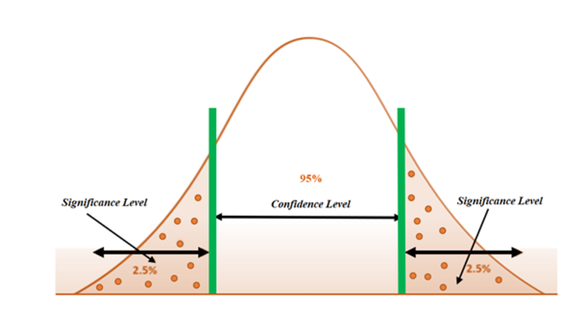

* **Confidence Level**:  
  The confidence level (e.g., 95%) is the probability that the confidence interval contains the true population parameter. It represents the degree of certainty that the result is correct. The higher the confidence level, the wider the interval.
* **Significance Level (α)**:  
  The significance level is the probability of rejecting the null hypothesis when it is actually true (i.e., making a Type I error). It is typically set at **0.05** (5%), but can be adjusted depending on the desired level of precision.

**Relationship**:  
The **confidence level** is equal to **1 - α**. For example, if the significance level is **0.05**, the confidence level is **95%** (i.e., 1 - 0.05 = 0.95 or 95%).

**Question 8**: *What is the difference between Point Estimate and Confidence Interval Estimate?*

**Answer**:

* **Point Estimate**:  
  A **point estimate** is a single value that serves as the best guess or approximation for a population parameter. For example, using the sample mean to estimate the population mean.
* **Confidence Interval Estimate**:  
  A **confidence interval** provides a range of values, not just a single estimate, within which the population parameter is likely to fall. It also includes a confidence level (e.g., 95%) indicating the likelihood that the interval contains the true parameter.

**Difference**:

* A **point estimate** gives one specific value, while a **confidence interval** gives a range of values along with a measure of uncertainty.

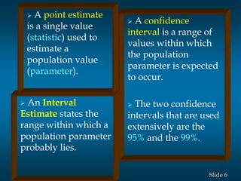

**Question 9**: *What do you understand about biased and unbiased terms?*

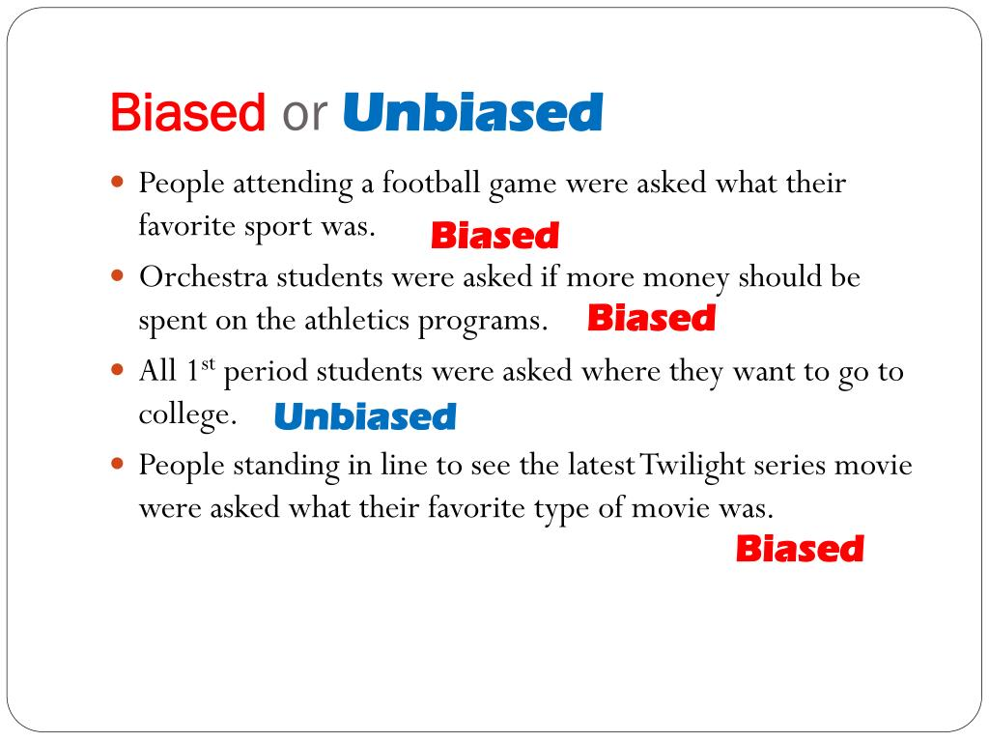**Answer**:

* **Biased**:  
  A statistic is said to be **biased** if it systematically overestimates or underestimates the true population parameter. A biased estimator does not provide accurate estimates on average.
* **Unbiased**:  
  A statistic is **unbiased** if its expected value is equal to the true population parameter. In other words, an unbiased estimator will provide the correct estimate on average, over many samples.

**Question 10**: *How does the width of the confidence interval change with length?*

**Answer**:  
The **width of a confidence interval** is determined by several factors, including the sample size, variability, and the confidence level. As the **sample size** increases, the width of the confidence interval **decreases** because a larger sample provides a more precise estimate of the population parameter.

* **Sample Size**: Larger sample sizes lead to narrower confidence intervals.
* **Confidence Level**: Higher confidence levels (e.g., 99% vs. 95%) result in wider confidence intervals because you want to be more certain that the interval contains the true parameter.

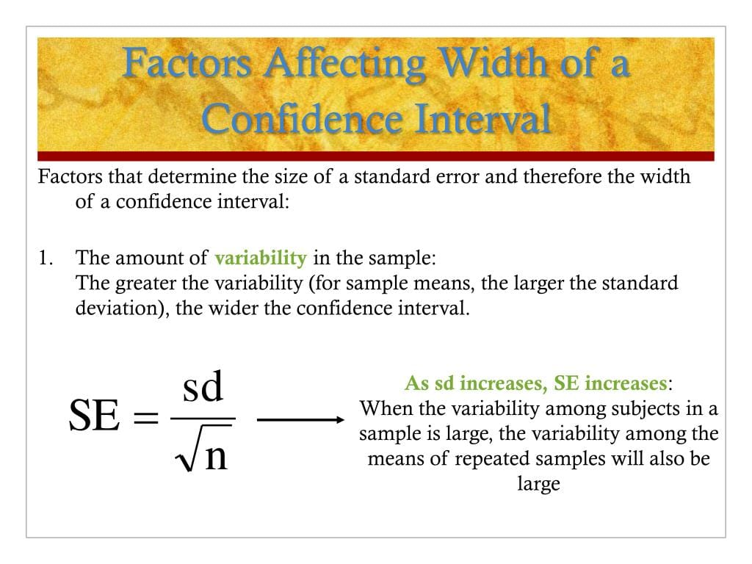

In summary, as the sample size increases, the confidence interval becomes **narrower**, leading to more precise estimates of the population parameter.

**Question 1**: *What is the meaning of standard error?*

**Answer**:

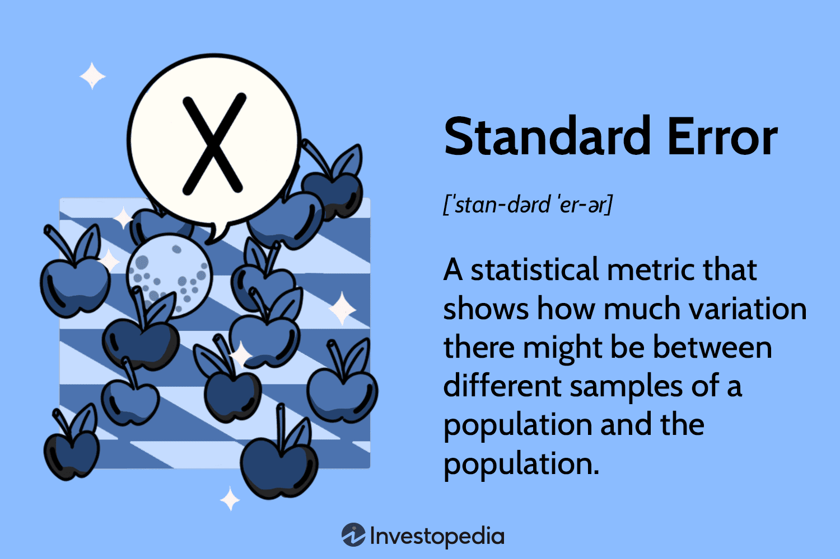  
The **standard error (SE)** is a measure of the **variability** or **precision** of a sample statistic, such as the sample mean, as an estimate of the population parameter. It indicates how much the sample mean is expected to fluctuate from the true population mean. The formula for standard error is:

SE=snSE = \frac{s}{\sqrt{n}}

Where:

* ss = sample standard deviation,
* nn = sample size.

A smaller standard error indicates more reliable estimates of the population parameter.

**Question 2**: *What is a Sampling Error and how can it be reduced?*

**Answer**:  
**Sampling error** is the difference between a sample statistic and the corresponding population parameter. It occurs because a sample is only a subset of the population, so the sample may not perfectly represent the population. Sampling error can be reduced by:

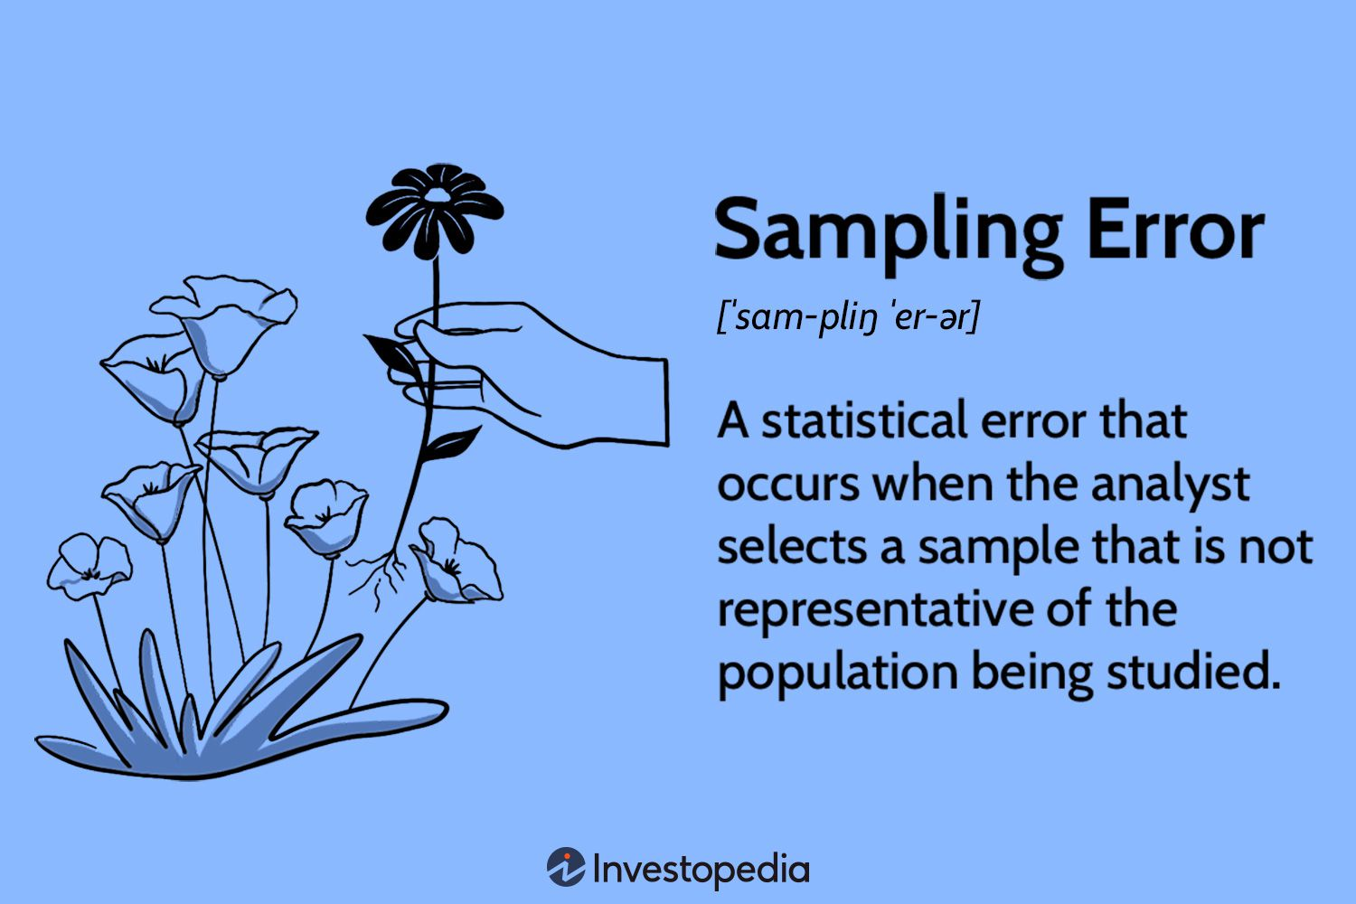

* **Increasing the Sample Size**:  
  Larger sample sizes tend to give more accurate estimates of the population parameters and reduce sampling error.
* **Using Random Sampling**:  
  Random sampling helps ensure that the sample is representative of the population, reducing bias and sampling error.
* **Using Stratified Sampling**:  
  Ensuring the sample includes all relevant subgroups or strata of the population can help reduce error. 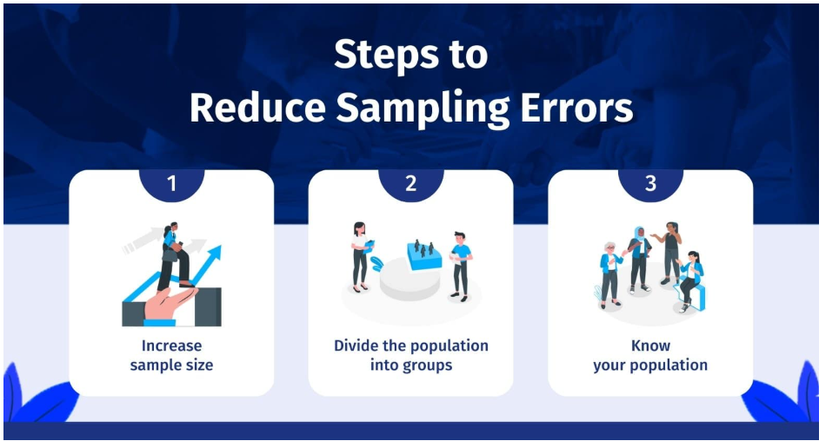

**Question 3**: *How do the standard error and the margin of error relate?*

**Answer**:  
The **standard error** (SE) is a measure of the variability of a sample statistic, while the **margin of error** is the range within which the true population parameter is likely to fall, given the standard error and the desired confidence level. The margin of error can be calculated using the formula:

Margin of Error=Z×SE\text{Margin of Error} = Z \times SE

Where:

* ZZ is the Z-score corresponding to the desired confidence level (e.g., 1.96 for 95% confidence),
* SESE is the standard error.

The larger the standard error, the wider the margin of error, indicating less precision in estimating the population parameter.

**Question 4**: *What is hypothesis testing?*

**Answer**:

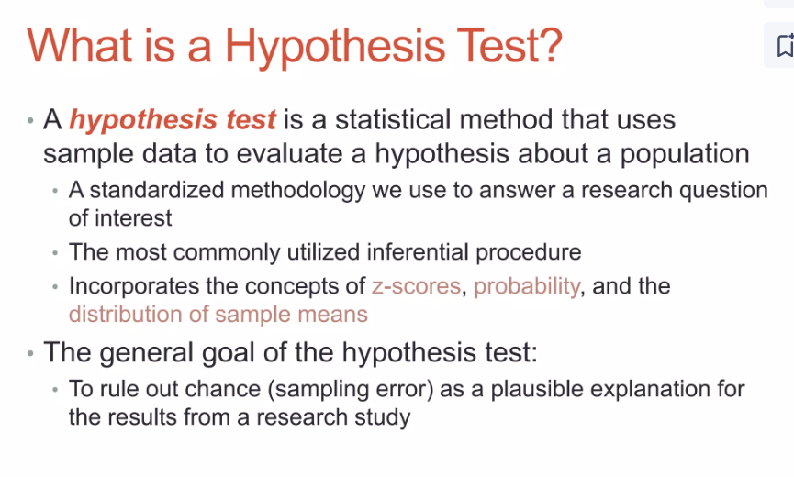  
**Hypothesis testing** is a statistical procedure used to assess the validity of a hypothesis about a population based on sample data. It involves:

* **Formulating Hypotheses**:
* Null hypothesis (H0H_0): A statement that there is no effect or no difference.
* Alternative hypothesis (H1H_1): A statement that there is an effect or difference.
* **Collecting Data**:  
  Data is collected from the sample.
* **Performing a Test**:  
  A statistical test (e.g., t-test, chi-squared test) is applied to determine whether the sample data provides sufficient evidence to reject the null hypothesis.
* **Making a Decision**:  
  Based on the p-value or test statistic, a conclusion is drawn—either rejecting or failing to reject the null hypothesis.

**Question 5**: *What is an alternative hypothesis?*

**Answer**:  
The **alternative hypothesis** (H1H_1 or HAH_A) is the hypothesis that suggests a relationship or effect exists between variables. It is the hypothesis that is tested against the null hypothesis. In the context of hypothesis testing, the alternative hypothesis posits that the population parameter differs from the value specified in the null hypothesis.

Example:

* Null hypothesis (H0H_0): The average height of men is 5'10".
* Alternative hypothesis (H1H_1): The average height of men is not 5'10".

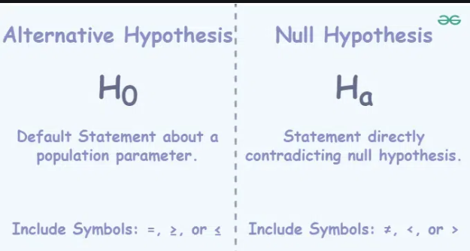

**Question 6**: *What is the difference between one-tailed and two-tailed hypothesis testing?*

**Answer**:

* **One-tailed hypothesis testing**:  
  A one-tailed test examines the direction of the effect. It tests whether the population parameter is either **greater than** or **less than** a certain value, but not both. For example, testing if the mean is **greater than** a certain value.
* **Example**: H0:μ≤50H_0: \mu \leq 50 vs H1:μ>50H_1: \mu > 50
* **Two-tailed hypothesis testing**:  
  A two-tailed test examines if the population parameter is **significantly different** from the hypothesized value in either direction. It tests for both **greater than** or **less than** conditions.
* **Example**: H0:μ=50H_0: \mu = 50 vs H1:μ≠50H_1: \mu \neq 50

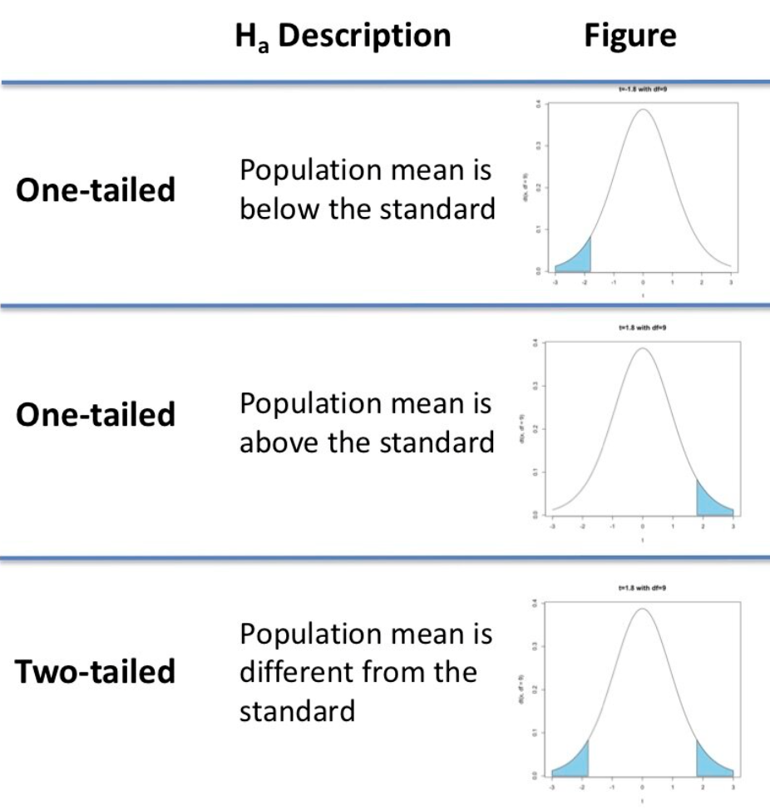

**Question 7**: *What is one sample t-test?*

**Answer**:  
A **one-sample t-test** is used to determine whether the mean of a single sample is significantly different from a known or hypothesized population mean. It is typically used when the population standard deviation is unknown and the sample size is small. The formula for the one-sample t-test is:

t=xˉ−μ0snt = \frac{\bar{x} - \mu_0}{\frac{s}{\sqrt{n}}}

Where:

* xˉ\bar{x} = sample mean,
* μ0\mu_0 = hypothesized population mean,
* ss = sample standard deviation,
* nn = sample size.

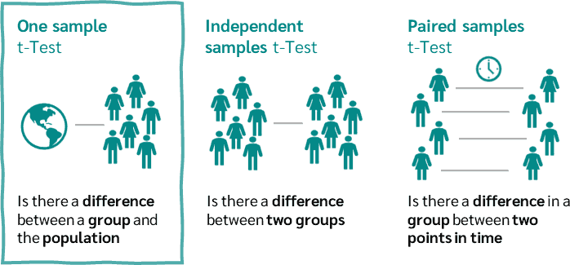

**Question 8**: *What is the meaning of degrees of freedom (DF) in statistics?*

**Answer**:  
**Degrees of freedom (DF)** refer to the number of independent values or quantities that can vary in a statistical calculation without violating any constraints. In hypothesis testing, degrees of freedom are used to determine the appropriate distribution for the test statistic.

For a **t-test** (one-sample), degrees of freedom are calculated as:

DF=n−1DF = n - 1

Where:

* nn = sample size.

The greater the degrees of freedom, the more closely the t-distribution approximates the normal distribution.

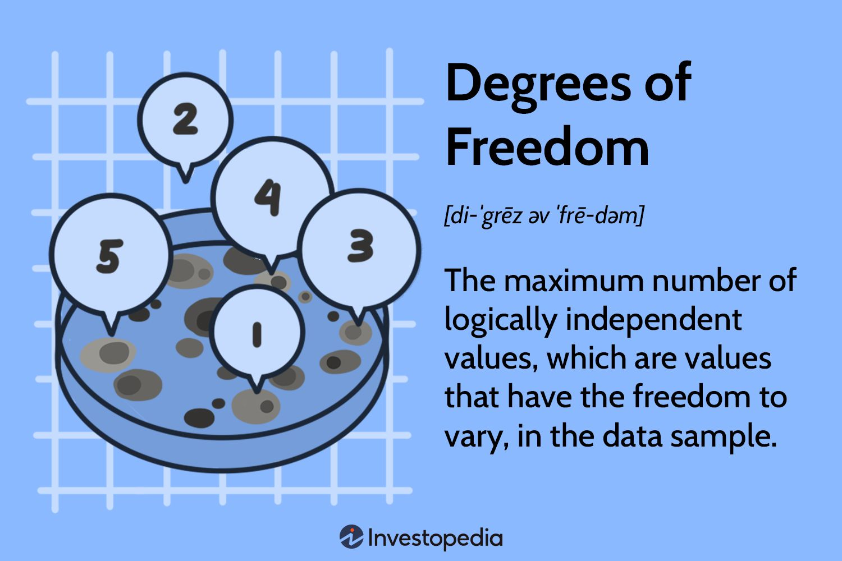

**Question 9**: *What is the p-value in hypothesis testing?*

**Answer**:  
The **p-value** is a probability that helps determine the strength of the evidence against the null hypothesis. It represents the likelihood of obtaining a test statistic at least as extreme as the one observed, under the assumption that the null hypothesis is true.

* **Smaller p-value**: Stronger evidence against the null hypothesis, making it more likely that you will reject it.
* **Larger p-value**: Weaker evidence against the null hypothesis, making it more likely that you will fail to reject it.

A common threshold for significance is α=0.05\alpha = 0.05, meaning a p-value less than 0.05 would lead to rejecting the null hypothesis.

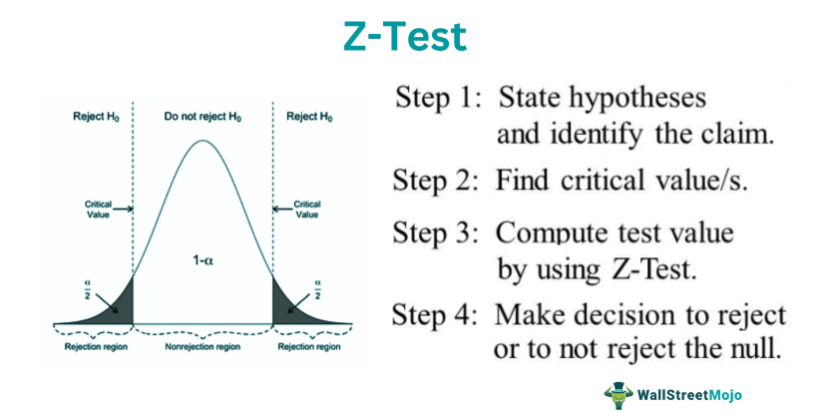

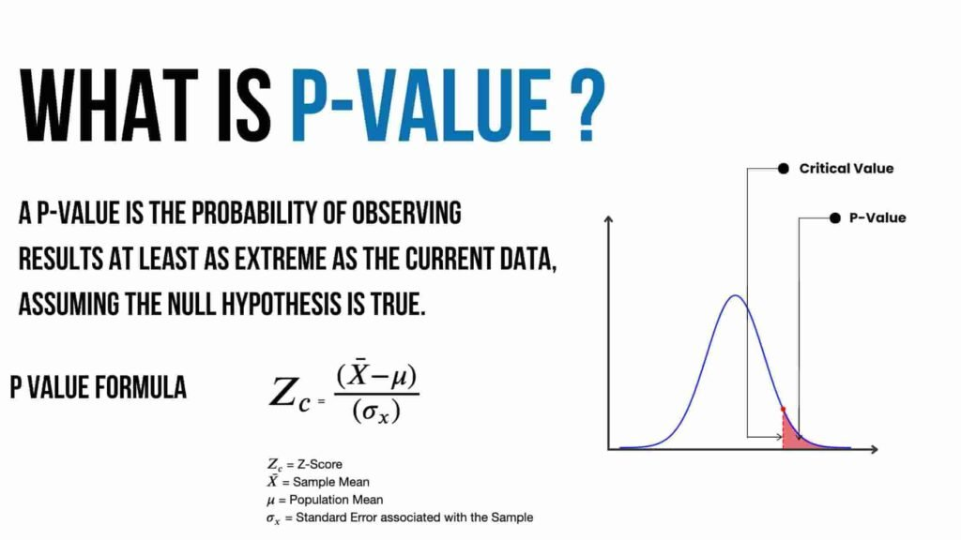**Question 10**: *How can you calculate the p-value?*

**Answer**:  
To calculate the **p-value**, you typically follow these steps:

* **Set up hypotheses**: Define the null hypothesis (H0H_0) and the alternative hypothesis (H1H_1).
* **Select the appropriate statistical test**: Choose the correct test (e.g., t-test, z-test) based on your data type and distribution.
* **Calculate the test statistic**: Compute the test statistic (e.g., t-value, z-value) using the sample data.
* **Use the test statistic to find the p-value**:
* For **t-tests**, use a t-distribution table or statistical software to find the p-value based on the calculated t-value and degrees of freedom.
* For **z-tests**, use a standard normal distribution table to find the p-value based on the calculated z-value.
* **Compare the p-value to the significance level**:  
  If the p-value is less than the significance level (α\alpha), reject the null hypothesis; otherwise, fail to reject the null hypothesis.

**Question 1**: *If there is a 30 percent probability that you will see a supercar in any 20-minute time interval, what is the probability that you will see at least one supercar in a period of an hour (60 minutes)?*

**Answer**:  
To calculate the probability of seeing at least one supercar in 60 minutes, we can treat this as a **complementary event**. The probability of not seeing a supercar in a 20-minute interval is 1−0.30=0.701 - 0.30 = 0.70. Since the events are independent, the probability of not seeing a supercar in 60 minutes (which consists of three 20-minute intervals) is:

P(no supercar in 60 minutes)=0.70×0.70×0.70=0.343P(\text{no supercar in 60 minutes}) = 0.70 \times 0.70 \times 0.70 = 0.343

Therefore, the probability of seeing at least one supercar in 60 minutes is:

P(at least one supercar in 60 minutes)=1−0.343=0.657P(\text{at least one supercar in 60 minutes}) = 1 - 0.343 = 0.657

So, there is a **65.7%** chance of seeing at least one supercar in 60 minutes.

**Question 2**: *How would you describe a ‘p-value’?*

**Answer**:  
The **p-value** is a probability that measures the strength of the evidence against the null hypothesis (H0H_0) in hypothesis testing. Specifically, the p-value tells us the probability of observing results as extreme as, or more extreme than, the data collected, assuming that the null hypothesis is true.

* **Small p-value (< 0.05)**: Provides strong evidence against H0H_0, suggesting that H0H_0 should be rejected.
* **Large p-value (≥ 0.05)**: Provides weak evidence against H0H_0, suggesting that there is not enough evidence to reject H0H_0.

**Question 3**: *What is the difference between type I vs type II errors?*

**Answer**:

* **Type I Error (False Positive)**: This occurs when the null hypothesis is rejected when it is actually true. It’s a "false alarm." The probability of a Type I error is denoted by α\alpha, also known as the **significance level**.
* **Type II Error (False Negative)**: This occurs when the null hypothesis is not rejected when it is actually false. It’s a "miss." The probability of a Type II error is denoted by β\beta.

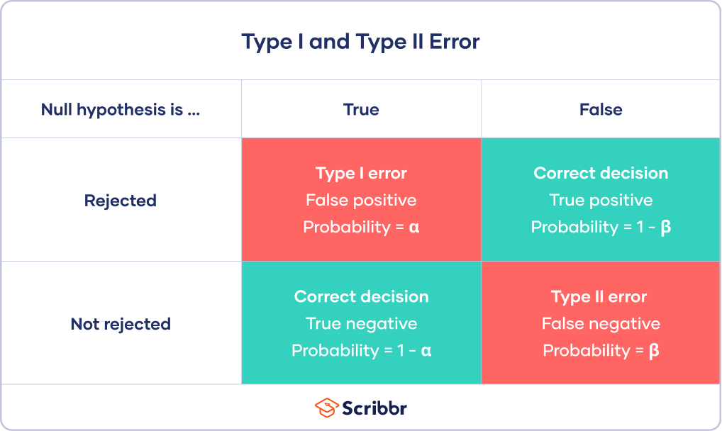

To minimize Type I errors, you reduce the significance level (α\alpha), but this can increase the risk of Type II errors. Similarly, increasing the sample size can reduce Type II errors while maintaining an acceptable Type I error rate.

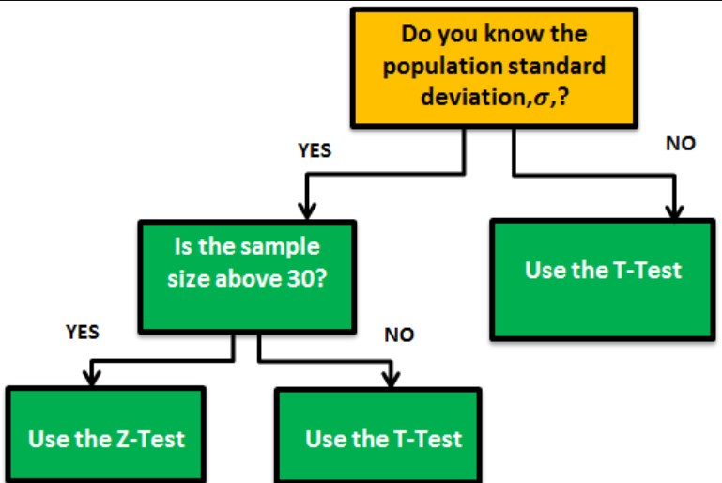**Question 4**: *When should you use a t-test vs a z-test?*

**Answer**:

* **t-test**: Use a **t-test** when:
* The sample size is small (typically n<30n < 30).
* The population standard deviation (σ\sigma) is unknown.
* The sample is assumed to come from a normally distributed population.
* **z-test**: Use a **z-test** when:
* The sample size is large (typically n≥30n \geq 30).
* The population standard deviation (σ\sigma) is known.
* The sample comes from a normally distributed population, or by the Central Limit Theorem, the sample size is large enough for the sampling distribution to approximate normality.

**Question 5**: *What is the difference between the f-test and anova test?*

**Answer**:

* **F-test**: The F-test is used to compare the variances of two populations or to test if a regression model fits the data. It is a general term for any statistical test that uses the F-distribution.
* **ANOVA (Analysis of Variance)**: ANOVA is a specific type of F-test used to compare the means of three or more groups to determine if there are any statistically significant differences between them. It works by analyzing the variance within groups and between groups.

In short, the F-test is used in ANOVA as a method to test whether the means of different groups are equal.

**Question 6**: *What is Resampling and what are the common methods of resampling?*

**Answer**:  
**Resampling** is a statistical technique in which multiple new samples are drawn from the existing data to assess the variability of a statistic. It is used to estimate the sampling distribution of a statistic, improve the precision of the estimated parameters, or assess the performance of a model.

Common methods of resampling include:

* **K-fold Cross-validation**: This method divides the dataset into kk equally sized subsets or folds. Each fold is used once as a test set while the remaining k−1k-1 folds are used for training. This process is repeated for each fold, and the results are averaged to get the final model performance.
* **Bootstrapping**: This method involves randomly sampling the dataset with replacement, so some observations can appear multiple times while others might be left out. Multiple resamples are created, and statistics are computed on each resample. The results are then averaged to get an estimate of the population parameter.

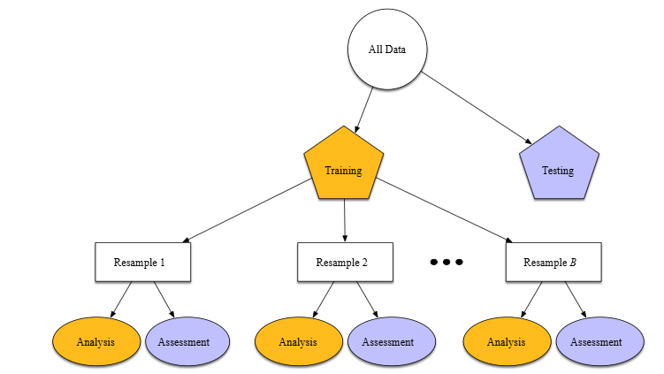

**Question 7**: *What is the proportion of confidence intervals that will not contain the population parameter?*

**Answer**:  
The proportion of confidence intervals that will not contain the population parameter is equal to the **significance level** (α\alpha), which is the complement of the confidence level. For instance:

* For a **95% confidence interval**, the proportion of intervals that will not contain the population parameter is 1−0.95=0.051 - 0.95 = 0.05, or **5%**.
* For a **99% confidence interval**, the proportion of intervals that will not contain the population parameter is 1−0.99=0.011 - 0.99 = 0.01, or **1%**.

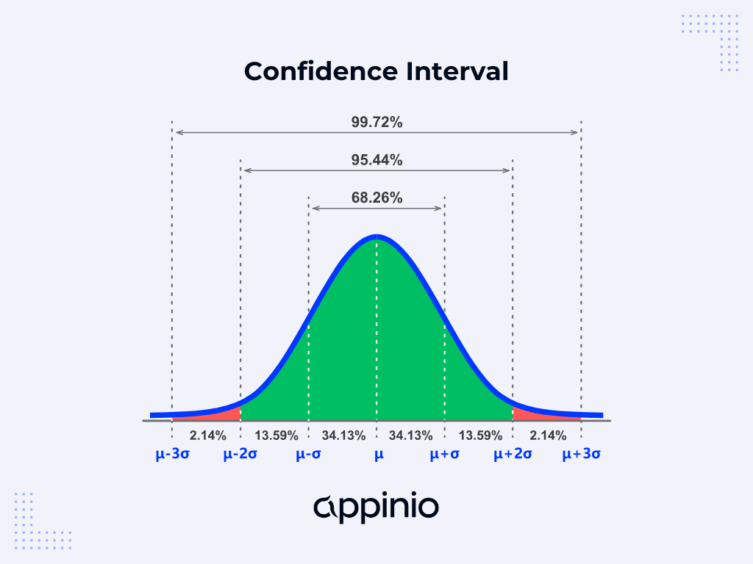

**Question 8**: *What is a confounding variable?*

**Answer**:  
A **confounding variable** is a third variable that influences both the independent and dependent variables, creating a false impression of the relationship between the variables of interest. Confounding can distort the apparent effect of the independent variable on the dependent variable, leading to misleading conclusions.

Example: If we are studying the relationship between physical exercise (independent variable) and weight loss (dependent variable), but diet (confounding variable) also affects weight loss, then failing to account for diet could lead to erroneous conclusions about the effect of exercise on weight loss.

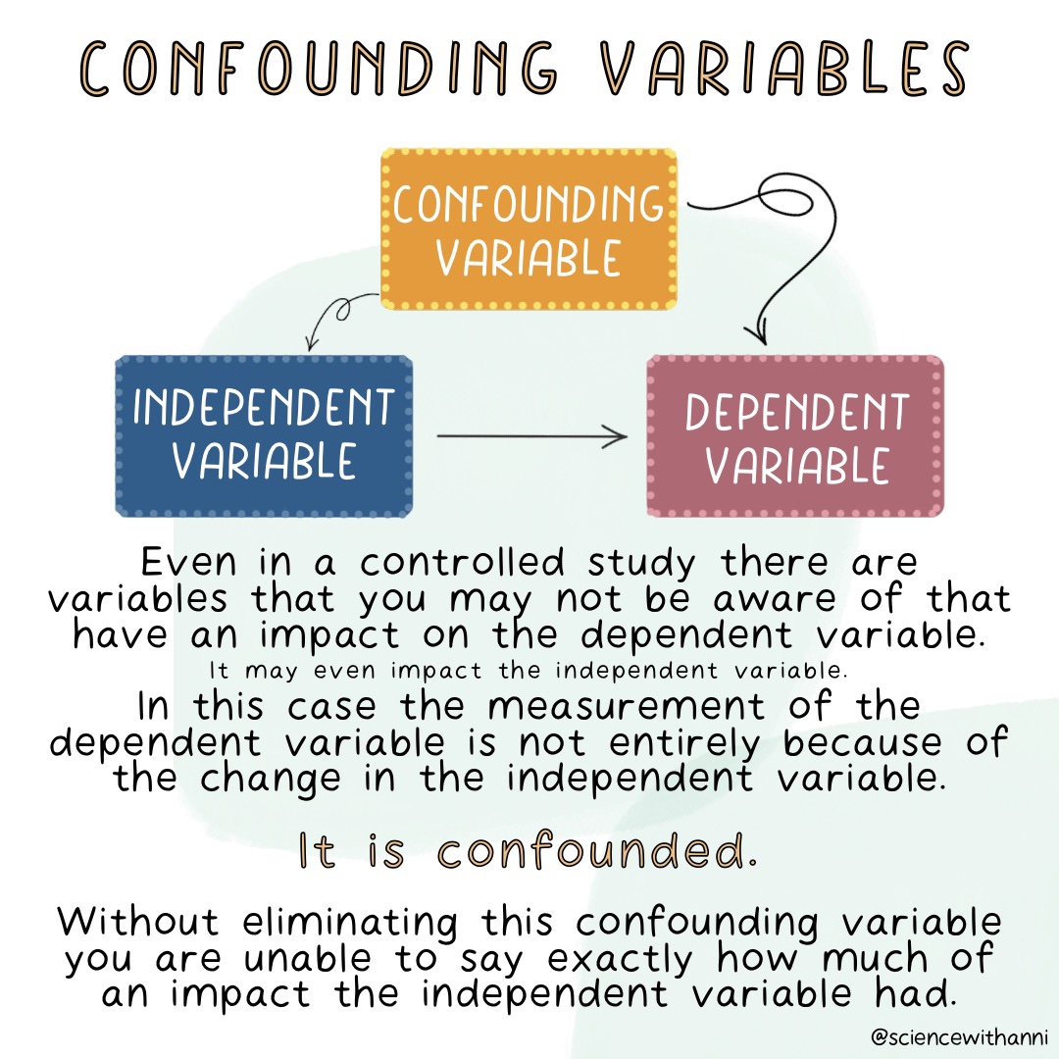

**Question 9**: *What are the steps we should take in hypothesis testing?*

**Answer**:  
The steps involved in hypothesis testing are:

* **State the Null Hypothesis (H₀)**: Define the assumption that there is no effect or difference in the population.
* **State the Alternative Hypothesis (H₁)**: Define the hypothesis that there is an effect or difference.
* **Select the Test and Test Statistic**: Choose the appropriate statistical test based on the data and hypotheses (e.g., t-test, chi-squared test).
* **Collect Data**: Gather sample data that will be used for testing the hypothesis.
* **Calculate the Test Statistic**: Compute the statistic using the sample data.
* **Construct Acceptance/Rejection Regions**: Define the critical region(s) based on the significance level (α\alpha).
* **Draw a Conclusion**: Based on the test statistic and the rejection region, decide whether to reject the null hypothesis or fail to reject it.

These steps help determine whether the observed data provides enough evidence to support the alternative hypothesis.

83. **Question 1: What is the relationship between standard error and the margin of error?**

**Answer**:  
The **standard error (SE)** measures the standard deviation of a sampling distribution, indicating the variability of sample means around the population mean. The **margin of error (MOE)** is the range within which the true population parameter is expected to lie, given a certain confidence level (usually 95% or 99%).

The relationship between the two is that the margin of error is typically calculated as:

Margin of Error=Z×Standard Error\text{Margin of Error} = Z \times \text{Standard Error}

Where:

* **Z** is the Z-score corresponding to the desired confidence level (e.g., 1.96 for 95% confidence).
* **Standard Error** is the standard deviation of the sampling distribution.

So, the margin of error depends on both the standard error and the confidence level. A larger sample size reduces the standard error, thus narrowing the margin of error.

**Question 2: How would you describe what a ‘p-value’ is to a non-technical person or in layman terms?**

**Answer**:  
Imagine you flip a coin and expect it to be fair, so heads and tails should each come up about half the time. A **p-value** helps us figure out if the results we get are surprising or if they could have happened by chance.

For example, let’s say you flip the coin 10 times and get heads 9 times. The **p-value** tells us how likely it is that you would get this result if the coin were actually fair (50/50 chance). A **small p-value** (like 0.01 or 1%) means it’s very unlikely that such a result happened by chance, so you might conclude the coin is biased.

In simple terms, if the **p-value** is smaller than a threshold (say, 0.05 or 5%), it suggests the result is statistically significant, and something other than just chance is likely at play.

**Question 3: What does interpolation and extrapolation mean? Which is generally more accurate?**

**Answer**:

* **Interpolation**: This is when you make predictions using values that are within the range of your existing data. For example, if you know the temperature at 10 AM and 12 PM, interpolation would be predicting the temperature at 11 AM, which is within the range of observed values.
* **Extrapolation**: This is when you make predictions for values outside the range of your data. For example, if you know the temperature at 10 AM and 12 PM, extrapolation would involve predicting the temperature at 1 PM, which is beyond the range of your observed data.

Generally, **interpolation** is more accurate because it relies on data points within the known range. **Extrapolation** carries more risk of inaccuracy since it involves making predictions outside of the observed data range, where patterns might not hold.

**Question 4: What is an inlier?**

**Answer**:  
An **inlier** is a data point that fits well within the overall pattern or trend of the dataset. It’s not an outlier, meaning it doesn't deviate significantly from the rest of the data. While outliers are extreme values that stand apart from the rest, inliers are typical values that conform to the expected distribution or trend in the data.

Inliers are not errors but are often just regular, expected data points. They are important because they help define the general behavior or pattern of the dataset.

**Question 5: You roll a biased coin (p(head) = 0.8) five times. What’s the probability of getting three or more heads?**

**Answer**:  
This is a **binomial probability problem** where the probability of getting heads on any single roll is 0.80.8, and the probability of getting tails is 0.20.2.

To calculate the probability of getting 3 or more heads in 5 rolls, we need to compute the probabilities of getting 3, 4, and 5 heads and then sum them up. The probability of getting exactly kk heads in nn rolls is given by the **binomial probability formula**:

P(X=k)=(nk)pk(1−p)n−kP(X = k) = \binom{n}{k} p^k (1-p)^{n-k}

Where:

* n=5n = 5 (the number of rolls),
* p=0.8p = 0.8 (the probability of heads),
* kk is the number of heads,
* (nk)\binom{n}{k} is the binomial coefficient.

We need to calculate P(X≥3)P(X \geq 3), which is the sum of the probabilities of getting 3, 4, or 5 heads:

P(X=3)+P(X=4)+P(X=5)P(X = 3) + P(X = 4) + P(X = 5)

Let's compute these probabilities:

* **P(X = 3)**:

P(X=3)=(53)(0.8)3(0.2)2=10×0.512×0.04=0.2048P(X = 3) = \binom{5}{3} (0.8)^3 (0.2)^2 = 10 \times 0.512 \times 0.04 = 0.2048

* **P(X = 4)**:

P(X=4)=(54)(0.8)4(0.2)1=5×0.4096×0.2=0.4096P(X = 4) = \binom{5}{4} (0.8)^4 (0.2)^1 = 5 \times 0.4096 \times 0.2 = 0.4096

* **P(X = 5)**:

P(X=5)=(55)(0.8)5(0.2)0=1×0.32768=0.32768P(X = 5) = \binom{5}{5} (0.8)^5 (0.2)^0 = 1 \times 0.32768 = 0.32768

Now, sum these probabilities:

P(X≥3)=0.2048+0.4096+0.32768=0.94208P(X \geq 3) = 0.2048 + 0.4096 + 0.32768 = 0.94208

So, the probability of getting 3 or more heads in 5 rolls of the biased coin is approximately **0.942** or **94.2%**.

88**88. Infection rates at a hospital above 1 infection per 100 person-days at risk are considered high. A hospital had 10 infections over the last 1787 person-days at risk. Give the p-value of the correct one-sided test of whether the hospital is below the standard.**

**Answer**: To test whether the hospital's infection rate is below the threshold of 1 infection per 100 person-days, we perform a one-sample proportion test.

* **Null hypothesis** H0H_0: The infection rate is at or above 1 infection per 100 person-days (p = 0.01).
* **Alternative hypothesis** HaH_a: The infection rate is less than 1 infection per 100 person-days (p < 0.01).

The sample infection rate is:

p^=101787=0.0056\hat{p} = \frac{10}{1787} = 0.0056

We will use the formula for the z-test for proportions:

z=p^−p0p0(1−p0)nz = \frac{\hat{p} - p_0}{\sqrt{\frac{p_0(1 - p_0)}{n}}}

Where:

* p^\hat{p} is the sample proportion (0.0056),
* p0p_0 is the hypothesized proportion (0.01),
* nn is the sample size (1787).

Substituting the values:

z=0.0056−0.010.01(1−0.01)1787z = \frac{0.0056 - 0.01}{\sqrt{\frac{0.01(1 - 0.01)}{1787}}} z=−0.00440.01×0.991787z = \frac{-0.0044}{\sqrt{\frac{0.01 \times 0.99}{1787}}} z=−0.00440.00237=−1.86z = \frac{-0.0044}{0.00237} = -1.86

Next, we look up the z-value in a standard normal distribution table to find the p-value. A z-score of -1.86 corresponds to a p-value of approximately **0.031**.

Since this is a one-sided test, the p-value is **0.031**.

**89. In a population of interest, a sample of 9 men yielded a sample average brain volume of 1,100cc and a standard deviation of 30cc. What is a 95% Student’s T confidence interval for the mean brain volume in this new population?**

**Answer**:  
To compute the confidence interval for the mean brain volume, we use the formula for a Student's t-confidence interval:

xˉ±tα/2×sn\bar{x} \pm t_{\alpha/2} \times \frac{s}{\sqrt{n}}

Where:

* xˉ=1100\bar{x} = 1100 is the sample mean,
* s=30s = 30 is the sample standard deviation,
* n=9n = 9 is the sample size,
* tα/2t_{\alpha/2} is the t-score for the 95% confidence level with n−1=8n-1 = 8 degrees of freedom.

From the t-distribution table, the critical t-value for α=0.05\alpha = 0.05 and 8 degrees of freedom is approximately **2.31**.

Now, compute the margin of error:

Margin of error=2.31×309=2.31×10=23.1\text{Margin of error} = 2.31 \times \frac{30}{\sqrt{9}} = 2.31 \times 10 = 23.1

So, the 95% confidence interval is:

1100±23.1=(1076.9,1123.1)1100 \pm 23.1 = (1076.9, 1123.1)

Thus, the 95% confidence interval for the mean brain volume is **(1076.9cc, 1123.1cc)**.

**90. What is a Chi-square test?**

**Answer**:  
The **Chi-square test** is a statistical method used to determine whether there is a significant association between categorical variables. It compares the observed frequencies in the data to the frequencies that would be expected under a null hypothesis.

* **Goodness-of-fit test**: Used to see if the data follows a specific distribution.
* **Test of independence**: Used to determine if two categorical variables are independent.

Example: A food delivery company might use the Chi-square test to see if there is an association between gender, location, and food preferences.

**91. What is the ANOVA test?**

**Answer**:  
The **ANOVA (Analysis of Variance)** test is used to compare the means of three or more groups to see if at least one group mean is significantly different from the others. It tests the null hypothesis that all group means are equal.

* **One-way ANOVA**: Used when there is one independent variable.
* **Two-way ANOVA**: Used when there are two independent variables.

ANOVA compares the variance within groups to the variance between groups. If the ratio is large, the null hypothesis (that all means are equal) is rejected.

**92. How to calculate p-value using a manual method?**

**Answer**:  
To manually calculate the p-value, follow these steps:

* **State the null and alternative hypotheses**.
* **Choose the appropriate statistical test** (e.g., z-test, t-test, chi-square test, etc.).
* **Compute the test statistic** (e.g., z, t, chi-square).
* **Find the p-value** by comparing the test statistic to the relevant distribution (e.g., normal, t-distribution, chi-square distribution).
* For a z-test, the p-value is the area under the curve beyond the computed z-value.
* For a t-test, use the t-distribution to find the p-value.
* For a chi-square test, compare the test statistic to the chi-square distribution.

**93. What do we mean by – making a decision based on comparing p-value with significance level?**

**Answer**:  
When performing hypothesis testing, we compare the **p-value** to a predefined **significance level** (α\alpha), typically set at 0.05. This helps us decide whether to reject the null hypothesis:

* If **p-value ≤ α**, we reject the null hypothesis, suggesting the result is statistically significant.
* If **p-value > α**, we fail to reject the null hypothesis, suggesting there is not enough evidence to support the alternative hypothesis.

**94. What is the goal of A/B testing?**

**Answer**:  
The goal of **A/B testing** is to compare two versions of a treatment (e.g., webpage, marketing message) to determine which one performs better. It involves randomly assigning participants to two groups (Group A and Group B) and measuring the outcome (e.g., conversion rate, user engagement). The version that shows a statistically significant better outcome is considered the best option.

**95. What is the difference between a box plot and a histogram?**

**Answer**:

* **Box plot**: A box plot is a graphical representation of the distribution of a dataset through its quartiles, highlighting the median, interquartile range (IQR), and potential outliers. It is useful for comparing distributions across multiple datasets.
* **Histogram**: A histogram is a bar chart that represents the frequency distribution of a continuous variable by dividing the data into bins or intervals. It shows how data is distributed across the range of values.

In short, **box plots** give a summary of key statistics (median, IQR, outliers), while **histograms** show the frequency distribution of the data.

95. **A jar has 1000 coins, of which 999 are fair and 1 is double-headed. Pick a coin at random, and toss it 10 times. Given that you see 10 heads, what is the probability that the next toss of that coin is also a head?**

To solve this problem, we can use **Bayes' Theorem** to determine the probability that the coin is the double-headed one, given that 10 heads were observed.

Let's define the events:

* C1C_1: The coin selected is a fair coin.
* C2C_2: The coin selected is the double-headed coin.
* H10H_{10}: The outcome of 10 heads in 10 tosses.

We need to find the probability of getting another head (i.e., P(Hnext∣H10)P(H_{\text{next}} | H_{10})).

By Bayes' Theorem:

P(C2∣H10)=P(H10∣C2)P(C2)P(H10)P(C_2 | H_{10}) = \frac{P(H_{10} | C_2) P(C_2)}{P(H_{10})}

Where:

* P(H10∣C2)=1P(H_{10} | C_2) = 1 (If the coin is double-headed, you will always get heads),
* P(C2)=11000P(C_2) = \frac{1}{1000} (The probability of selecting the double-headed coin),
* P(H10)=P(H10∣C1)P(C1)+P(H10∣C2)P(C2)P(H_{10}) = P(H_{10} | C_1) P(C_1) + P(H_{10} | C_2) P(C_2).

Now, we compute the components:

* P(H10∣C1)=(12)10P(H_{10} | C_1) = \left(\frac{1}{2}\right)^{10} (If the coin is fair, the probability of 10 heads in a row is (12)10\left(\frac{1}{2}\right)^{10}),
* P(C1)=9991000P(C_1) = \frac{999}{1000}.

So, the total probability P(H10)P(H_{10}) is:

P(H10)=(12)10×9991000+1×11000P(H_{10}) = \left(\frac{1}{2}\right)^{10} \times \frac{999}{1000} + 1 \times \frac{1}{1000} P(H10)=(1210)×9991000+11000P(H_{10}) = \left( \frac{1}{2^{10}} \right) \times \frac{999}{1000} + \frac{1}{1000} P(H10)≈9991024×1000+11000=0.0009766+0.001=0.0019766P(H_{10}) \approx \frac{999}{1024 \times 1000} + \frac{1}{1000} = 0.0009766 + 0.001 = 0.0019766

Now, applying Bayes’ theorem:

P(C2∣H10)=1×110000.0019766≈0.505P(C_2 | H_{10}) = \frac{1 \times \frac{1}{1000}}{0.0019766} \approx 0.505

Thus, the probability that the coin is double-headed, given that we observed 10 heads, is approximately 50.5%.

The probability that the next toss is a head is:

P(Hnext∣H10)=P(Hnext∣C2)×P(C2∣H10)+P(Hnext∣C1)×P(C1∣H10)P(H_{\text{next}} | H_{10}) = P(H_{\text{next}} | C_2) \times P(C_2 | H_{10}) + P(H_{\text{next}} | C_1) \times P(C_1 | H_{10}) P(Hnext∣H10)=1×0.505+12×0.495=0.505+0.2475=0.7525P(H_{\text{next}} | H_{10}) = 1 \times 0.505 + \frac{1}{2} \times 0.495 = 0.505 + 0.2475 = 0.7525

So, the probability that the next toss will also be a head is approximately **0.7525** or **75.25%**.

**96. What is a confidence interval and how do you interpret it?**

**Answer**:  
A **confidence interval (CI)** is a range of values, derived from a sample, that is used to estimate an unknown population parameter. The interval is constructed so that, if the sampling were repeated many times, the true population parameter would lie within the interval in a specified percentage of the cases.

For example, a 95% confidence interval means that if you were to take 100 different samples and compute the interval for each sample, 95 of the intervals would contain the true population parameter.

Interpretation:

* If a 95% confidence interval for the population mean is (100, 110), we can say we are 95% confident that the true population mean lies between 100 and 110.

**110. How do you stay up-to-date with the new and upcoming concepts in statistics?**

**Answer**:  
To stay up-to-date with new concepts in statistics, one can:

* **Follow academic journals**: Read journals like *Journal of the American Statistical Association* (JASA), *Biometrika*, and *The Annals of Statistics* for new research.
* **Attend conferences**: Participate in or attend statistical conferences such as the Joint Statistical Meetings (JSM) or data science summits.
* **Online courses and MOOCs**: Platforms like Coursera, edX, and Udemy offer courses on the latest statistical techniques and methods.
* **Engage with online communities**: Participate in forums like Stack Exchange (Cross Validated) or follow data science blogs to engage with current trends and debates.
* **Social media and influencers**: Follow statisticians, data scientists, and academics on Twitter and LinkedIn for insights into new methodologies.
* **Books and textbooks**: Keep an eye on new editions of leading statistics textbooks or specialized books on emerging topics like machine learning statistics, Bayesian methods, etc.

**97. What is correlation?**

**Answer**:  
**Correlation** is a statistical measure that expresses the extent to which two variables are linearly related. It indicates how one variable changes when the other variable changes. The correlation coefficient (r) ranges from -1 to +1:

* r=+1r = +1 indicates a perfect positive relationship.
* r=−1r = -1 indicates a perfect negative relationship.
* r=0r = 0 indicates no linear relationship.

Correlation does not imply causation; it merely quantifies the strength and direction of the relationship between two variables.

**98. What types of variables are used for Pearson’s correlation coefficient?**

**Answer**:  
Pearson’s correlation coefficient is used to measure the strength and direction of the linear relationship between **two continuous variables**. These variables must be interval or ratio scale measurements. For example, height and weight, or income and spending, are examples of continuous variables that can be used with Pearson’s correlation.

**99. In an observation, there is a high correlation between the time a person sleeps and the amount of productive work he does. What can be inferred from this?**

**Answer**:  
A **high correlation** between the time a person sleeps and the amount of productive work they do suggests that there may be a relationship between the two variables. However, **correlation does not imply causation**. The high correlation may indicate that:

* Getting more sleep could lead to higher productivity, or
* People who are more productive may tend to get more sleep due to better health or lifestyle.

To draw a definitive conclusion about causality, further investigation and controlled experiments would be needed to determine whether sleep directly influences productivity or whether other factors are involved.

100**100. What is the meaning of covariance?**

Covariance is a measure of the relationship between two variables. It indicates the extent to which two variables change together. If the covariance is positive, it means that as one variable increases, the other tends to increase as well (positive relationship). If the covariance is negative, it means that as one variable increases, the other tends to decrease (negative relationship). A covariance of zero suggests that the variables are independent of each other (though not necessarily unrelated).

However, covariance does not standardize the measure, so it depends on the units of the variables, which makes it difficult to interpret on its own. It is often used in calculating the correlation coefficient, which standardizes the relationship between two variables.

**101. What does autocorrelation mean?**

Autocorrelation, also known as serial correlation, is the correlation of a signal with a delayed copy of itself as a function of the delay. In simpler terms, autocorrelation measures how a variable at one time point is related to its value at another time point. It is commonly used in time series data to assess the degree of similarity between a variable's values at different time lags.

For example, in stock market analysis, autocorrelation might help understand whether the price of a stock today is related to the price in previous days.

**102. What types of variables are used for Pearson’s correlation coefficient?**

Pearson's correlation coefficient measures the linear relationship between **two continuous variables**. These variables must be of interval or ratio scale. The data should ideally be normally distributed, and the relationship between the variables should be linear. Examples of suitable variables include:

* Height and weight
* Temperature and pressure
* Income and spending

Pearson's correlation is **not** suitable for categorical variables or ordinal data, as it assumes continuous, interval-scaled data.

**103. How will you determine the test for the continuous data?**

When determining which statistical test to use for continuous data, several factors need to be considered:

* **Normality of the Data**: If the data is normally distributed, you can use parametric tests such as the t-test, ANOVA, or Pearson’s correlation. If the data is not normally distributed, you may opt for non-parametric tests like the Mann-Whitney U test, Wilcoxon signed-rank test, or Spearman’s rank correlation.
* **Number of Samples**:
* For one sample, you might use a one-sample t-test.
* For comparing two groups, you can use an independent or paired t-test.
* For comparing more than two groups, ANOVA is typically used.
* **Relationships Between Variables**: If you're interested in the relationship between two continuous variables, Pearson's correlation is used, while for more complex relationships, linear or logistic regression may be appropriate.

The choice of test depends on the data's distribution, the number of groups, and the hypotheses you are testing.

**104. What can be the reason for non-normality of the data?**

Non-normality of data can arise due to several reasons, including:

* **Outliers**: Extreme values in the data that don't conform to the overall pattern can skew the distribution, making it non-normal.
* **Skewness**: If the data has a long tail on one side, it may exhibit positive or negative skewness, deviating from normality.
* **Heteroscedasticity**: When the variance of the data is not constant across all levels, it can cause the data to deviate from normality.
* **Multimodal Distribution**: If the data comes from different underlying distributions (for example, two different populations), it may result in a bimodal or multimodal distribution.
* **Sample Size**: For small sample sizes, the central limit theorem may not apply, leading to deviations from normality.

In cases of non-normality, data transformation techniques (e.g., log transformation) may be applied to make the data more normal.

**105. Why is there no such thing as a 3-sample t-test? Why does the t-test fail with 3 samples?**

The reason there is no "three-sample t-test" is because the **t-test** is designed for comparing **two groups** or **two sets of data**. If you have more than two groups, a **t-test** would not be appropriate. The **t-test** compares the means of two independent groups, and applying it to three groups would involve multiple comparisons, which could lead to an inflated Type I error (i.e., incorrectly rejecting the null hypothesis).

When you have **three or more groups**, the appropriate test is **Analysis of Variance (ANOVA)**. ANOVA allows you to test if there are any statistically significant differences between the means of three or more groups.

**Note for everyone:**

Write all the answer in a detailed and beautiful way include images and all if required with respect to answer and create a pdf of that and send it to me at my mail id: [sunny.savita@ineuron.ai](mailto:sunny.savita@ineuron.ai)

**Once I will get all the answers I will evaluate and the best one I will share on my linkedin and even krish naik sir will repost it**.

**The deadline is Friday till 9PM IST.**